Preliminary Design and Performance Analysis of an Aircraft Environmental Control System

Mechanical Engineering Project
Prepared by Mohana Lotfi

Mechanical Engineering
Concordia University
Montréal, Québec, Canada
August 2026

Executive Summary
This project developed and validated a preliminary aircraft environmental control system for cooling an avionics/electronics equipment compartment under a representative 10,000 ft design condition. The objective was to create a technically traceable ECS model integrating thermal-load estimation, airflow sizing, duct pressure losses, heat-exchanger performance, fan power, system-level sensitivity analysis, robust design selection, off-design assessment, and three-dimensional CFD validation.
A closed recirculating avionics-air loop was selected, with heat rejected through an air-to-air heat exchanger to a separate external cooling-air stream. The developed net avionics-zone thermal load was $2581.6 \text{W}$ and the original minimally sized baseline required approximately $0.1713 \text{kg/s}$ of recirculation airflow to maintain a 25°C supply temperature and 40°C zone temperature.
The baseline model was integrated in MATLAB and independently checked through energy balances, pressure-loop closure, Reynolds-number evaluation, and low-Mach-number verification. The initial design was found to be physically feasible but to provide essentially zero thermal reserve.
A multi-parameter sensitivity analysis was therefore performed. Heat-exchanger thermal conductance was identified as the strongest controllable thermal-robustness variable, with local zone-temperature sensitivity approximately 2.73 times greater than the corresponding percentage sensitivity to recirculation airflow. Duct diameter was identified as the strongest normalized fan-power design variable near the baseline, while heat-exchanger pressure drop remained a major aerodynamic uncertainty and component-selection consideration.
A 50-case robust-design sweep was subsequently conducted by varying duct diameter, airflow, and heat-exchanger conductance. Twenty configurations satisfied both nominal and stressed thermal requirements. A final robust design candidate was selected with $\boxed{D=0.200 \text{m}}$, $\boxed{\dot{m}=0.18838 \text{kg/s}}$ and $\boxed{UA=102.22 \text{W/K}}$
The selected design reduced the conservative modeled system pressure loss to $143.96 \text{Pa}$ while fan input power was approximately $56.9 \text{W}$
At the nominal condition, the selected configuration predicted an avionics-zone temperature of approximately ${32.4}^{∘}\text{C}$
At the combined robustness condition of 10% increased thermal load and 10% reduced effective heat-exchanger conductance, the predicted zone temperature remained below the 40°C limit at ${39.21}^{∘}\text{C}$ providing a remaining margin of approximately ${0.795}^{∘}\text{C}$
Off-design analysis showed that, at the baseline external cooling condition, the selected system could accommodate approximately $20.7\%$
additional avionics thermal load before reaching the maximum zone-temperature requirement. At baseline thermal load, the maximum allowable external cooling-air temperature was approximately ${2.81}^{∘}\text{C}$
A continuous operating-envelope curve was developed to quantify the combined effects of thermal load and external cooling-air temperature.
The selected duct network was then independently evaluated using three-dimensional CFD in SOLIDWORKS Flow Simulation. A controlled mesh-refinement study increased the model from approximately 10,000 to 136,000 solver cells. The two finest meshes differed in predicted pressure drop by approximately 2.57%, and the finest-mesh duct-network pressure drop was $\boxed{26.83 \text{Pa}}$
A geometry-matched one-dimensional model predicted $44.30 \text{Pa}$ indicating that the analytical model was conservative for the modeled smooth long-radius duct geometry. The CFD-derived effective elbow loss coefficient was approximately $K_{\text{eff}}=0.146$ compared with the preliminary analytical assumption of 0.30.
For final fan sizing, the conservative analytical pressure-loss basis was retained rather than replacing it with the lower CFD value. This produced an overall design pressure requirement of $143.96 \text{Pa}$ compared with a CFD-informed system estimate of approximately $126.83 \text{Pa}$ providing approximately 11.9% aerodynamic sizing margin.
The completed design passed all final thermal, aerodynamic, energy-balance, low-Mach, turbulent-flow, robustness, CFD-stability, and operating-envelope checks. The project therefore demonstrates a complete preliminary ECS design workflow progressing from first-principles sizing through system integration, sensitivity analysis, robust configuration selection, off-design performance assessment, and independent three-dimensional CFD validation.

Table of Contents
Executive Summary i
Project Objective 1
1. System Architecture 1
2. Baseline Design Definition 2
3. Thermal and Flow Fundamentals 2
4. Baseline ECS Architecture and State-Point Definition 3
5. Avionics Compartment Thermal Load Model 4
6. Required Cooling Airflow Analysis 6
7. Duct Network and Pressure-Loss Model 7
8. Heat Exchanger Performance Model 9
9. Integrated ECS System Model 10
10. Fan Power Requirement and Thermal Refinement 12
11. Baseline ECS Performance Assessment 13
12. Sensitivity Analysis and Design Drivers 15
Thermal-Load Sensitivity 15
External Cooling-Air Temperature Sensitivity 17
Recirculation-Airflow Sensitivity 18
Duct-Diameter Sensitivity 18
Heat-Exchanger Pressure-Drop Sensitivity 19
Fan-Efficiency Sensitivity 19
Heat-Exchanger Thermal-Performance Sensitivity 19
Overall Sensitivity Findings 20
13. Robust Design Selection and Independent Validation 21
14. Off-Design and Operational Performance 22
External Cooling-Air Temperature Envelope 22
Fixed-Hardware Thermal-Load Envelope 23
Combined Thermal-Load and Environmental Operating Envelope 23
Nominal Cooling Modulation 24
Operational Assessment 25
15. CFD Validation of the Selected Duct Network 25
CFD Boundary Conditions 25
Mesh-Convergence Study 26
CFD-Matched Analytical Model 26
Analytical-to-CFD Comparison 27
Engineering Interpretation 27
CFD Flow-Field Observations 27
16. Final Design Validation and Design Freeze 29
17. Conclusions 32
18. Limitations and Future Work 33
19.1 Component-Level Data 33
19.2 Thermal Model 34
19.3 Environmental and Flight Conditions 34
19.4 Duct and CFD Model 34
19.5 Control and Dynamic Behavior 34
19.6 Experimental Validation 34
19.7 Future Development Path 35
References 35
Appendices 35

Project Objective
The objective of this project is to develop and evaluate a simplified aircraft Environmental Control System (ECS) for thermal management of an avionics/electronics compartment. The system will use conditioned forced airflow to remove internal heat loads while maintaining the compartment below a specified temperature limit. The analysis will quantify the required cooling capacity, airflow rate, heat-exchanger performance, duct pressure losses, and fan power requirement. The design will also be evaluated using sensitivity studies, energy-balance checks, and quantitative comparison of alternative design conditions.
The project is intended as a preliminary engineering design study rather than a detailed reproduction of a proprietary aircraft ECS. The emphasis is on thermodynamics, heat transfer, internal flow, system integration, validation, and engineering tradeoffs.

System Architecture
The preliminary ECS uses a closed recirculating-air loop to cool an aircraft avionics/electronics compartment. Warm air leaving the avionics compartment is moved by a fan through a duct network and then through an air-to-air heat exchanger. The heat exchanger transfers thermal energy from the avionics airflow to a separate external cooling-air stream. The cooled avionics air is then returned to the compartment.
The avionics and external cooling-air streams remain physically separated inside the heat exchanger. The external stream acts as the heat sink and is exhausted after absorbing heat. The recirculating avionics stream provides continuous cooling without directly introducing outside air into the electronics compartment.
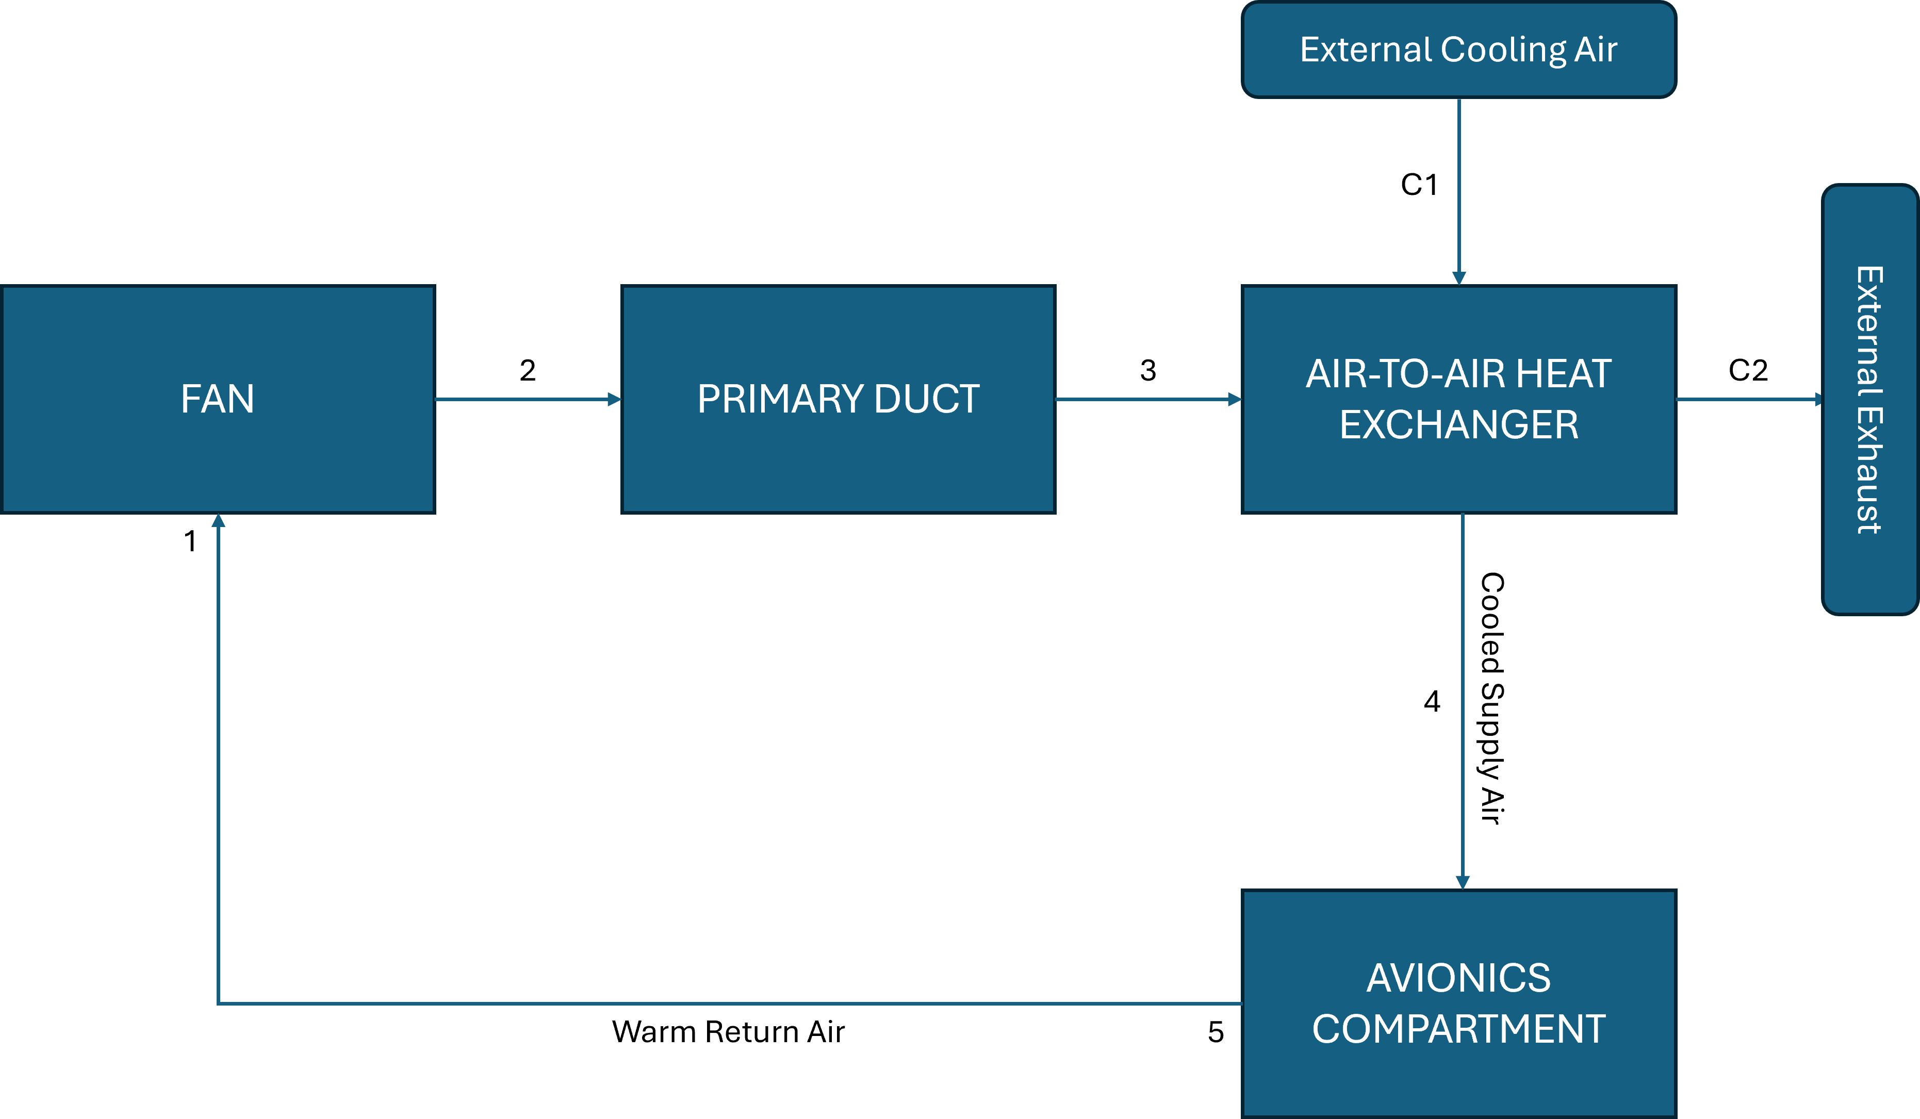
Figure 1. Preliminary aircraft environmental control system architecture showing the closed avionics-air recirculation loop and separate external cooling-air heat-rejection stream.

Baseline Design Definition
The preliminary system models forced-air thermal management of an aircraft avionics/electronics compartment. The avionics-side air is recirculated through a duct network and an air-to-air heat exchanger, while a separate external-air stream acts as the heat sink.
The baseline design condition is an assumed cruise altitude of 10,000 ft (3048 m). Standard-atmosphere conditions at this altitude are used to define the external cooling-air inlet state, with an approximate temperature of −4.8°C, pressure of 69.7 kPa, and density of 0.905 kg/m³.
The preliminary thermal-design requirements are:
- Maximum avionics-compartment bulk-air temperature: 40°C
- Preliminary supply-air temperature target: 25°C
- Preliminary thermal load: 3000 W
- Required cooling capacity must equal or exceed the compartment thermal load
- The fan must overcome the total pressure loss of the recirculating-air loop
- The final integrated model must conserve energy within a numerical error target of less than 1%
The initial model assumes steady-state operation, one-dimensional bulk duct flow, a well-mixed avionics compartment, ideal-gas behavior for air, negligible duct-wall heat transfer, negligible leakage, and no mixing between the two heat-exchanger streams. Airflow compressibility will initially be neglected only if the calculated Mach number remains below 0.3. Reynolds number and relative roughness will be evaluated before selecting any duct friction-factor correlation.
The 40°C temperature limit, 25°C supply-air target, 3000 W heat load, and 10,000 ft operating altitude are preliminary engineering design assumptions rather than manufacturer-specific aircraft data. The standard-atmosphere properties are reference-derived values. The thermal load will be developed in greater detail during the thermal-load phase.

Thermal and Flow Fundamentals
The preliminary ECS analysis is based on steady-state conservation of energy applied to the avionics compartment. Neglecting shaft work, elevation changes, and significant kinetic-energy changes across the compartment, the steady-flow energy equation reduces to ${\dot{Q}}_{\text{load}}\dot{m}c_{p}\left(T_{\text{zone}}-T_{\text{supply}}\right)$ where ${\dot{Q}}_{\text{load}}$is the compartment thermal load, $\dot{m}$is the recirculating-air mass flow rate, $c_{p}$is the specific heat of air, $T_{\text{zone}}$is the compartment bulk-air temperature, and $T_{\text{supply}}$ is the conditioned supply-air temperature.
For the preliminary baseline condition, ${\dot{Q}}_{\text{load}}=3000 \text{W}$, $T_{\text{zone}}={40}^{∘}\text{C}$, $T_{\text{supply}}={25}^{∘}\text{C}$, and $c_{p}=1005 \text{J/(kg·K)}$ giving an allowable air-temperature rise of $ΔT=15 \text{K}$ and a required recirculating-air mass flow rate of $\dot{m}\frac{3000}{1005\left(15\right)}0.199 \text{kg/s}$.
Using the mean avionics-loop temperature of ${32.5}^{∘}\text{C},$ the ideal-gas relation was used with the preliminary loop pressure of $69.7 \text{kPa}$to estimate an air density of approximately $ρ_{\text{av}}=0.794 {\text{kg/m}}^{3}$.
The corresponding volumetric airflow is $\dot{V}\frac{\dot{m}}{ρ}≈0.251 {\text{m}}^{3}/\text{s}$.
These values establish the preliminary airflow requirement but do not yet define the duct diameter. Duct geometry will be selected after evaluating velocity, Reynolds number, Mach number, pressure loss, and fan-power trade-offs.
Pressure losses in the ECS will be modeled as the sum of major and minor losses. Straight-duct friction will be calculated using $ΔP_{\text{major}}f\frac{L}{D}\frac{ρV^{2}}{2}$ while fittings and other localized losses will be represented using $ΔP_{\text{minor}}K\frac{ρV^{2}}{2}$
The friction factor will not be prescribed arbitrarily. Reynolds number, $Re=\frac{ρVD}{μ}$ will first be calculated to determine the flow regime, after which an appropriate friction-factor relation will be selected. Compressibility will also be checked using Mach number before accepting the low-speed duct-flow approximation.
The air-to-air heat exchanger transfers energy from the warm recirculating avionics stream to a separate external cooling-air stream. The heat-capacity rate of each stream is defined as $C=\dot{m}c_{p}$
For the preliminary avionics airflow, $C_{h}≈200 \text{W/K}$
Heat-exchanger performance will be evaluated using the effectiveness relation $ε\frac{{\dot{Q}}_{\text{actual}}}{C_{min}\left(T_{h,in}-T_{c,in}\right)}$
where $C_{min}$is the smaller heat-capacity rate of the two streams. With a hot-stream inlet of ${40}^{∘}\text{C}$and external-air inlet of $-{4.8}^{∘}\text{C},$the available inlet-temperature difference is $44.8 \text{K}$. If the external-stream heat-capacity rate is at least as large as the avionics-stream heat-capacity rate, the preliminary minimum effectiveness required to reject the $3.0 \text{kW}$thermal load is approximately 0.335. This value is conditional and will be recalculated once the external cooling-air flow is defined.
The Phase 1 calculations establish the governing thermal and flow relationships required for the later component models. The preliminary $0.199 \text{kg/s}$airflow requirement remains subject to revision when the detailed thermal-load model is developed.

Baseline ECS Architecture and State-Point Definition
The baseline Environmental Control System consists of a closed recirculating avionics-air loop and a separate external cooling-air stream. Warm air leaving the avionics compartment is drawn through a fan, transported through the primary duct, and cooled in an air-to-air heat exchanger before returning to the compartment. A separate external-air stream passes through the cold side of the heat exchanger, absorbs energy from the avionics airflow, and is then exhausted. The two streams exchange thermal energy without mixing.
The recirculating avionics loop is represented by five state points. State 1 is located at the fan inlet on the warm return-air line. State 2 represents the fan outlet, where the principal change is an increase in pressure. State 3 is the heat-exchanger hot-side inlet following the primary duct. State 4 is the heat-exchanger hot-side outlet and represents the cooled supply air delivered to the avionics compartment. State 5 is the avionics-compartment outlet after the air has absorbed the internal thermal load. The external heat-exchanger stream is represented by states C1 and C2 at the cooling-air inlet and outlet, respectively.
The fan pressure rise is defined by $ΔP_{\text{fan}}=P_{2}-P_{1}$ and the required fan input power will later be calculated from ${\dot{W}}_{\text{fan}}\frac{ΔP_{\text{fan}}\dot{V}}{η_{f}}$
The primary duct produces a pressure reduction between states 2 and 3. Straight-duct and fitting losses will be modeled using $ΔP_{\text{duct}}f\frac{L}{D}\frac{ρV^{2}}{2}+\sum{K}\frac{ρV^{2}}{2}$ after the Reynolds number and appropriate friction-factor relation have been established.
The heat exchanger removes energy from the recirculating avionics stream. Its heat-transfer rate will be modeled using the effectiveness method, ${\dot{Q}}_{\text{HX}}εC_{min}\left(T_{3}-T_{C1}\right)$ where $C_{min}\min\left({\dot{m}}_{\text{av}}c_{p},{\dot{m}}_{c}c_{p}\right)$
The resulting avionics-side outlet temperature is $T_{4}T_{3}-\frac{{\dot{Q}}_{\text{HX}}}{{\dot{m}}_{\text{av}}c_{p}}$ while the external cooling-air outlet temperature is $T_{C2}T_{C1}+\frac{{\dot{Q}}_{\text{HX}}}{{\dot{m}}_{c}c_{p}}$
Energy conservation across the heat exchanger will require the heat removed from the avionics stream to approximately equal the heat gained by the external stream.
Within the avionics compartment, the conditioned air absorbs the imposed thermal load. The compartment energy balance is ${\dot{Q}}_{\text{load}}{\dot{m}}_{\text{av}}c_{p}\left(T_{5}-T_{4}\right)$ or equivalently, $T_{5}T_{4}+\frac{{\dot{Q}}_{\text{load}}}{{\dot{m}}_{\text{av}}c_{p}}$
The thermal design requirement is $T_{5}≤{40}^{∘}\text{C}$
The baseline model assumes negligible heat transfer along the return path, giving approximately $T_{1}≈T_{5}$ and negligible temperature changes through the fan and primary duct for the initial low-speed model.
Around the complete recirculating flow loop, the fan pressure rise must balance the total aerodynamic resistance: $ΔP_{\text{fan}}≈ΔP_{\text{duct}}+ΔP_{\text{HX}}+ΔP_{\text{compartment}}+ΔP_{\text{return}}$
The state-point architecture establishes a common framework for the subsequent thermal-load, airflow, pressure-loss, heat-exchanger, and integrated MATLAB models. Numerical values will only be assigned to state variables as the corresponding component models are developed and validated.

Avionics Compartment Thermal Load Model
The baseline avionics-compartment cooling requirement was developed from individual heat-load contributions rather than retaining the initial lumped 3.0 kW sizing assumption. The thermal model includes avionics electrical dissipation, heat transfer through the compartment boundary, and an auxiliary internal-load term.
The net compartment thermal load is defined as ${\dot{Q}}_{\text{total}}{\dot{Q}}_{\text{avionics}}+{\dot{Q}}_{\text{boundary}}+{\dot{Q}}_{\text{aux}}$
The avionics electrical load was represented using four functional equipment groups. Representative engineering design allocations of 1200 W for computing and processing electronics, 750 W for power-conversion and control electronics, 450 W for communications and navigation electronics, and 300 W for data, recording, and interface electronics were used. These values are preliminary rack-level design assumptions rather than equipment data from a specific aircraft.
Table 1. Baseline avionics-compartment thermal-load breakdown used to establish the ECS cooling requirement.
Thermal-load component | Heat transfer (W) | Role
Computing and processing electronics | 1200 | Internal heat generation
Power-conversion and control electronics | 750 | Internal heat generation
Communications and navigation electronics | 450 | Internal heat generation
Data, recording, and interface electronics | 300 | Internal heat generation
Gross avionics electrical load | 2700 | Total equipment dissipation
Compartment boundary heat transfer | -118.4 | Passive heat rejection
Auxiliary internal load | 0 | None assumed
Net compartment thermal load | 2581.6 | Required ECS cooling load

The resulting avionics heat dissipation is ${\dot{Q}}_{\text{avionics}}1200+750+450+3002700 \text{W}$
Because electrical power consumed by equipment located within the conditioned compartment is assumed to ultimately appear as heat within the zone, this electrical dissipation constitutes the dominant internal thermal load.
Heat transfer between the compartment and its surrounding structure was represented using ${\dot{Q}}_{\text{boundary}}UA\left(T_{\text{sur}}-T_{\text{zone}}\right)$
A representative rectangular compartment with dimensions $L=1.2 \text{m}, W=1.0 \text{m}, H=0.8 \text{m}$ was assumed. The corresponding enclosure surface area is $A2\left(LW+LH+WH\right)5.92 {\text{m}}^{2}$
Using an assumed effective overall heat-transfer coefficient of $U=1.0 {\text{W/(m}}^{2}\text{·K)}$ an effective surrounding structural temperature of $T_{\text{sur}}={20}^{∘}\text{C}$ and the limiting compartment temperature of $T_{\text{zone}}={40}^{∘}\text{C}$ gives ${\dot{Q}}_{\text{boundary}}\left(1.0\right)\left(5.92\right)\left(20-40\right)-118.4 \text{W}$
The negative sign indicates that the avionics compartment loses heat to its surroundings under the baseline condition, providing a small passive-cooling contribution rather than an additional thermal load.
No additional auxiliary internal load was included in the baseline model because no separate load could be justified without introducing an arbitrary assumption. Therefore, ${\dot{Q}}_{\text{aux}}=0$ and the resulting net thermal load is ${\dot{Q}}_{\text{total}}2700-118.42581.6 \text{W}$ or $\boxed{{\dot{Q}}_{\text{total}}≈2.582 \text{kW}}$
Avionics electrical dissipation represents approximately 104.6% of the net cooling requirement, while boundary heat transfer contributes approximately -4.6%. The percentage contribution of the avionics load exceeds 100% because passive heat rejection through the compartment boundary reduces the final net cooling demand.
The developed baseline thermal load is approximately 14.0% below the original 3.0 kW preliminary sizing value. The original value was therefore retained only as an initial conservative sizing estimate and was replaced by the traceable Phase 3 thermal-load model for subsequent calculations.
Using the developed thermal load and the baseline temperature difference of $T_{\text{zone}}-T_{\text{supply}}40-2515 \text{K}$ the required avionics-air mass flow becomes ${\dot{m}}_{\text{av}}\frac{2581.6}{1005\left(15\right)}0.1713 \text{kg/s}$
Using the representative avionics-loop density, the corresponding volumetric flow rate is approximately ${\dot{V}}_{\text{av}}≈0.216 {\text{m}}^{3}/\text{s}$
The thermal-load model was independently checked by recalculating the enclosure surface area, boundary heat transfer, total thermal load, and required cooling airflow. Substitution of the calculated airflow back into $\dot{Q}\dot{m}c_{p}ΔT$ reproduced the 2581.6 W thermal load to numerical precision. The compartment-boundary contribution is only approximately 4.4% of the gross avionics heat generation, indicating that the overall cooling requirement is primarily controlled by electronics power dissipation rather than the simplified enclosure heat-transfer model.
The accepted baseline thermal load for subsequent ECS analysis is therefore $\boxed{{\dot{Q}}_{\text{baseline}}=2581.6 \text{W}}$ with a corresponding baseline cooling-air mass-flow requirement of $\boxed{{\dot{m}}_{\text{av}}=0.1713 \text{kg/s}}$ under the current 25°C supply-air and 40°C compartment-temperature conditions.

Required Cooling Airflow Analysis

The required recirculating-air flow was determined from the developed baseline thermal load of ${\dot{Q}}_{\text{load}}=2581.6 \text{W}$ using the steady-state sensible-energy relation ${\dot{Q}}_{\text{load}}\dot{m}c_{p}\left(T_{\text{zone}}-T_{\text{supply}}\right)$ or $\dot{m}\frac{{\dot{Q}}_{\text{load}}}{c_{p}\left(T_{\text{zone}}-T_{\text{supply}}\right)}$
The maximum avionics-compartment bulk-air temperature was retained at $T_{\text{zone}}={40}^{∘}\text{C}$ and four supply-air temperatures were evaluated: $T_{\text{supply}}15, 20, 25, {30}^{∘}\text{C}$
The resulting required mass-flow rates were approximately 0.1028, 0.1284, 0.1713, and 0.2569 kg/s, respectively. The 25°C supply-air case remains the baseline condition, requiring $\boxed{{\dot{m}}_{\text{baseline}}≈0.1713 \text{kg/s}}$
Table 2. Required recirculation airflow as a function of supply-air temperature for the developed 2581.6 W avionics thermal load.
Supply-air temperature (°C) | Allowable temperature rise (°C) | Required mass flow (kg/s) | Relative to baseline
15 | 25 | 0.1028 | -40%
20 | 20 | 0.1284 | -25%
25 | 15 | 0.1713 | Baseline
30 | 10 | 0.2569 | +50%

Using a representative avionics-loop air density of approximately $ρ_{\text{av}}≈0.794 {\text{kg/m}}^{3}$ the baseline volumetric flow rate is approximately $\boxed{{\dot{V}}_{\text{baseline}}≈0.216 {\text{m}}^{3}/\text{s}}$
The airflow requirement increases nonlinearly as the supply-air temperature approaches the allowable compartment temperature. Relative to the 25°C baseline, reducing the supply temperature to 20°C decreases the required mass flow by approximately 25%, while reducing it to 15°C decreases the required mass flow by approximately 40%. Increasing the supply temperature to 30°C increases the required mass flow by approximately 50%.
This behavior follows directly from $\dot{m}∝\frac{1}{T_{\text{zone}}-T_{\text{supply}}}$ and demonstrates an important system-level trade-off. Colder supply air reduces the required airflow and therefore has the potential to reduce duct velocity, pressure loss, and fan power. However, producing colder supply air requires greater heat-exchanger performance. Conversely, warmer supply air reduces the required heat-exchanger temperature reduction but substantially increases the airflow requirement.
For the representative compartment volume of $V_{\text{zone}}=0.96 {\text{m}}^{3}$ the baseline volumetric flow corresponds to a nominal compartment-volume turnover time of approximately $t_{\text{turnover}}\frac{V_{\text{zone}}}{\dot{V}}≈4.45 \text{s}$
This turnover time is used only as a descriptive recirculation metric and is not treated as an aircraft certification requirement.
The airflow calculations were independently checked by substituting each calculated mass-flow rate back into ${\dot{Q}}_{\text{check}}\dot{m}c_{p}\left(T_{\text{zone}}-T_{\text{supply}}\right)$
All four supply-temperature cases reproduced the baseline thermal load of approximately 2581.6 W, confirming consistency between the thermal-load and airflow calculations.
The current volumetric-flow sensitivity uses a common representative air density for comparison between cases. Local temperature- and pressure-dependent density will be incorporated later in the integrated ECS model.
The 25°C supply-air condition and corresponding flow rate of approximately 0.1713 kg/s are retained as the baseline for subsequent duct sizing and pressure-loss analysis.

Duct Network and Pressure-Loss Model
A preliminary circular-duct network was defined to quantify the pressure losses associated with circulating the required cooling airflow through the ECS. The baseline network consists of three duct sections with a total straight length of 4.5 m and five 90° elbows. A common diameter was initially used throughout the loop to isolate the influence of duct size on velocity and pressure loss.
Three candidate diameters were evaluated: $D=0.150, 0.175, 0.200 \text{m}$ with $\boxed{D_{\text{baseline}}=0.175 \text{m}}$ selected as the preliminary baseline geometry.
Table 3. Candidate circular-duct sizing comparison for the baseline avionics recirculation airflow.
Candidate | Diameter (m) | Area (m²) | Velocity (m/s) | Reynolds Number | Darcy Friction Factor | Mach Number
Small | 0.150 | 0.01767 | 12.196 | 77,734 | 0.01889 | 0.0348
Baseline | 0.175 | 0.2405 | 8.961 | 66.629 | 0.01952 | 0.0256
Large | 0.200 | 0.03142 | 6.860 | 58,300 | 0.02009 | 0.0196

Using the current baseline volumetric flow rate of approximately ${\dot{V}}_{\text{av}}≈0.216 {\text{m}}^{3}/\text{s}$
the corresponding duct velocities were approximately 12.2 m/s, 9.0 m/s, and 6.9 m/s for the 150 mm, 175 mm, and 200 mm candidates, respectively. The baseline 175 mm duct therefore operates at approximately $\boxed{V_{\text{baseline}}≈8.96 \text{m/s}}$
The flow regime was evaluated using $Re=\frac{ρVD}{μ}$ with a representative air dynamic viscosity of $μ≈1.87×{10}^{-5} \text{Pa·s}$ at the mean avionics-loop temperature. Reynolds numbers for the candidate ducts were on the order of $6×{10}^{4}\text{ to }8×{10}^{4}$ and the baseline case produced approximately $\boxed{Re_{\text{baseline}}≈6.7×{10}^{4}}$ confirming turbulent internal flow.
A smooth-metal duct roughness of $ε=1.5×{10}^{-6} \text{m}$ was adopted as a preliminary engineering assumption. The Darcy friction factor was calculated using the Swamee–Jain turbulent-flow correlation,
$$f=\frac{0.25}{{\left[\log_{10}\left(\frac{ε}{3.7D}+\frac{5.74}{Re^{0.9}}\right)\right]}^{2}}$$
The resulting friction factors were approximately 0.019–0.020 across the candidate diameter range.
Straight-duct pressure losses were calculated using the Darcy–Weisbach relation, $ΔP_{\text{major}}f\frac{L}{D}\frac{ρV^{2}}{2}$
For the baseline 175 mm duct, the three modeled straight sections produced approximately 7.12 Pa, 3.56 Pa, and 5.34 Pa of pressure loss, giving $\boxed{ΔP_{\text{major,total}}16.01 \text{Pa}}$
The five 90° elbows were represented using $ΔP_{\text{minor}}K\frac{ρV^{2}}{2}$ with a preliminary long-radius elbow coefficient of $K=0.30$ per elbow. The resulting total elbow pressure loss was $\boxed{ΔP_{\text{elbows}}47.85 \text{Pa}}$ demonstrating that localized fitting losses exceed the straight-duct friction loss in the current compact network.
Because a detailed heat-exchanger passage geometry has not yet been selected, its aerodynamic resistance could not be derived directly. A preliminary avionics-side heat-exchanger pressure drop of $ΔP_{\text{HX}}=100 \text{Pa}$ was therefore introduced as an explicit design assumption. This value will be treated as an uncertainty and sensitivity parameter rather than as manufacturer-specific hardware data.
The resulting baseline system pressure loss is $ΔP_{\text{system}}ΔP_{\text{major}}+ΔP_{\text{elbows}}+ΔP_{\text{HX}}$ giving $\boxed{ΔP_{\text{system}}163.86 \text{Pa}}$
Table 4. Baseline ECS pressure-loss breakdown for the 175 mm duct configuration.
Pressure-loss component | Pressure loss (Pa) | Contribution (%)
Straight ducts | 16.01 | 9.77
90° elbows | 47.85 | 29.20
Heat exchanger | 100.00 | 61.03
Total system | 163.86 | 100.00

The pressure-loss breakdown indicates that the assumed heat exchanger accounts for approximately 61.0% of the total system resistance, the elbows contribute approximately 29.2%, and the straight ducts contribute approximately 9.8%. Under the present assumptions, reducing heat-exchanger resistance or improving fitting geometry would therefore have a greater effect on system pressure loss than simply shortening the straight duct sections.
The low-speed-flow assumption was checked using $Ma=\frac{V}{a}$ with $a=\sqrt{γRT}$
At the representative loop temperature, the speed of sound is approximately 350.5 m/s. The resulting Mach numbers for the 150 mm, 175 mm, and 200 mm ducts were approximately 0.035, 0.026, and 0.020, respectively. The baseline value, $\boxed{Ma_{\text{baseline}}≈0.026}$ is far below 0.3, supporting the neglect of compressibility effects in the preliminary duct model.
The total baseline pressure change of approximately 164 Pa is also small relative to the approximately 69.7 kPa absolute operating pressure. The pressure change is only about 0.24% of the absolute pressure, supporting the use of approximately constant density within individual duct sections.
The Phase 5 analysis therefore establishes a validated preliminary duct-flow model with turbulent, low-Mach-number internal flow. The current baseline design uses a 175 mm duct, approximately 8.96 m/s flow velocity, and a total modeled pressure loss of approximately 163.9 Pa. The heat-exchanger pressure-drop assumption and elbow loss coefficient remain important uncertainties that will be evaluated in later sensitivity studies.

Heat Exchanger Performance Model
The baseline air-to-air heat exchanger transfers heat from the recirculating avionics-air stream to a colder external-air stream. The hot side is defined by the avionics return flow, while the cold side is defined by external cooling air at the selected cruise design condition.
The baseline hot-side mass flow is ${\dot{m}}_{h}=0.1713 \text{kg/s}$ with an inlet temperature of $T_{h,in}={40}^{∘}\text{C}$ and a target outlet temperature of $T_{h,out}={25}^{∘}\text{C}$
The required heat rejection is equal to the developed compartment thermal load, ${\dot{Q}}_{\text{HX,req}}=2581.6 \text{W}$
The external cooling stream enters the heat exchanger at $T_{c,in}=-{4.8}^{∘}\text{C}$
A baseline cold-to-hot mass-flow ratio of 1.5 was adopted as an engineering design assumption, giving ${\dot{m}}_{c}1.5{\dot{m}}_{h}0.2569 \text{kg/s}$
The heat-capacity rates of the two streams are $C_{h}={\dot{m}}_{h}c_{p}$ and $C_{c}={\dot{m}}_{c}c_{p}$ which give $C_{h}=172.11 \text{W/K}$ and $C_{c}=258.16 \text{W/K}$
Therefore, $C_{min}=172.11 \text{W/K}$ and $C_{max}=258.16 \text{W/K}$ with the recirculating avionics stream acting as the minimum-capacity stream.
The maximum thermodynamically possible heat-transfer rate for the specified inlet conditions is ${\dot{Q}}_{max}C_{min}\left(T_{h,in}-T_{c,in}\right)$
Using the inlet-temperature difference $T_{h,in}-T_{c,in}40-\left(-4.8\right)44.8 \text{K}$ gives $\boxed{{\dot{Q}}_{max}=7710.4 \text{W}}$
The heat-exchanger effectiveness required to reject the full avionics thermal load is $ε_{\text{req}}\frac{{\dot{Q}}_{\text{HX,req}}}{{\dot{Q}}_{max}}$ giving $\boxed{ε_{\text{req}}=0.3348}$ or approximately 33.5%.
The resulting hot-side outlet temperature is calculated from $T_{h,out}T_{h,in}\frac{{\dot{Q}}_{\text{HX}}}{C_{h}}$
which gives $\boxed{T_{h,out}={25.0}^{∘}\text{C}}$ and therefore satisfies the baseline supply-air target.
The external-air outlet temperature is $T_{c,out}T_{c,in}+\frac{{\dot{Q}}_{\text{HX}}}{C_{c}}$ giving $\boxed{T_{c,out}={5.2}^{∘}\text{C}}$
Thus, the avionics stream is cooled by 15 K while the external stream warms by approximately 10 K.
The heat-transfer rate was independently recalculated from both sides of the heat exchanger: ${\dot{Q}}_{h}C_{h}\left(T_{h,in}-T_{h,out}\right)$ and ${\dot{Q}}_{c}C_{c}\left(T_{c,out}-T_{c,in}\right)$
Both calculations produced $\boxed{{\dot{Q}}_{h}{\dot{Q}}_{c}2581.6 \text{W}}$ with a numerical heat-exchanger energy-balance error of approximately $1.8×{10}^{-14}$ which is effectively zero.
A counterflow effectiveness–NTU representation was also used to estimate the thermal conductance required to achieve the baseline effectiveness. The heat-capacity-rate ratio is $C_{r}\frac{C_{min}}{C_{max}}0.667$
For a counterflow heat exchanger, $ε=\frac{1-e^{-NTU\left(1-C_{r}\right)}}{1-C_{r}e^{-NTU\left(1-C_{r}\right)}}$
Solving for the NTU required to achieve the baseline effectiveness gives $\boxed{NTU≈0.465}$
Using $NTU=\frac{UA}{C_{min}}$ the corresponding overall thermal conductance is $UA=NTU,C_{min}$
which gives approximately $\boxed{UA≈80.1 \text{W/K}}$
Table 5. Baseline air-to-air heat-exchanger performance at the developed ECS design condition.
Parameter | Value | Unit
Hot-side mass flow | 0.1713 | kg/s
Cold-side mass flow | 0.2569 | kg/s
Hot-side capacity rate, C_{h} | 172.11 | W/K
Cold-side capacity rate, C_{c} | 258.16 | W/K
Minimum capacity rate, C_{min} | 172.11 | W/K
Maximum possible heat transfer | 7710.38 | W
Required heat transfer | 2581.60 | W
Required effectiveness, ε | 0.3348 | —
NTU | 0.4653 | —
Required U A | 80.09 | W/K
Hot-side outlet temperature | 25.00 | °C
Cold-side outlet temperature | 5.20 | °C

The baseline heat exchanger therefore requires approximately 33.5% effectiveness, an NTU of 0.465, and a conductance of approximately 80 W/K to cool the avionics airflow from 40°C to 25°C at the current design point. The selected cold-side mass-flow ratio of 1.5 remains a design assumption and will be evaluated later through sensitivity analysis.

Integrated ECS System Model

The previously developed thermal-load, airflow, duct-network, and heat-exchanger models were combined into a single MATLAB-based Environmental Control System model. The integrated model calculates the required cooling airflow, thermophysical state, duct-flow conditions, pressure losses, heat-exchanger performance, and system state points directly from the baseline engineering inputs.
The developed avionics thermal load of ${\dot{Q}}_{\text{load}}=2581.6 \text{W}$ and the baseline temperature requirement of $T_{\text{zone}}={40}^{∘}\text{C}$ with a target supply temperature of $T_{\text{supply}}={25}^{∘}\text{C}$ produce a required recirculating-air mass flow of $\boxed{{\dot{m}}_{\text{av}}=0.1713 \text{kg/s}}$
The corresponding calculated volumetric flow is approximately $\boxed{{\dot{V}}_{\text{av}}=0.2155 {\text{m}}^{3}/\text{s}}$
Using the 175 mm baseline duct, MATLAB predicts an average duct velocity of $\boxed{V=8.961 \text{m/s}}$ with a Reynolds number of $\boxed{Re=6.66×{10}^{4}}$ and a Mach number of $\boxed{Ma=0.0256}$ confirming turbulent, low-Mach-number internal flow.
The integrated Darcy–Weisbach and minor-loss model produced 16.01 Pa of straight-duct friction loss and 47.85 Pa of elbow loss. Including the preliminary 100 Pa heat-exchanger pressure-drop assumption gives a total avionics-loop pressure loss of $\boxed{ΔP_{\text{system}}=163.86 \text{Pa}}$
The corresponding pressure-loss contributions are approximately 9.77% from the straight ducts, 29.20% from the elbows, and 61.03% from the heat exchanger.
The integrated heat-exchanger model uses a cold-side mass flow of ${\dot{m}}_{c}=0.2569 \text{kg/s}$ corresponding to the baseline cold-to-hot mass-flow ratio of 1.5. The hot- and cold-stream capacity rates are 172.11 W/K and 258.16 W/K, respectively. The required heat-exchanger effectiveness is $\boxed{ε_{\text{req}}=0.3348}$ which provides the required heat rejection of $\boxed{{\dot{Q}}_{\text{HX}}=2581.6 \text{W}}$
The resulting avionics-side outlet temperature is $\boxed{T_{h,out}={25.0}^{∘}\text{C}}$ while the external cooling-air temperature increases from $-{4.8}^{∘}\text{C}$ to approximately $\boxed{T_{c,out}={5.2}^{∘}\text{C}}$
The effectiveness–NTU calculation gives $NTU=0.4653$ and a corresponding required conductance of $\boxed{UA=80.09 \text{W/K}}$
The MATLAB model also calculates the principal ECS state points. Using the fan-inlet pressure as the 69.7 kPa reference, the fan raises the loop pressure by 163.86 Pa. Pressure subsequently decreases through the primary duct, heat exchanger, supply path, and return path until the loop returns to the original fan-inlet pressure.
The baseline state-point temperatures and pressures are summarized by the integrated model as follows: State 1, fan inlet, 40.0°C and 69.700 kPa; State 2, fan outlet, 40.0°C and 69.864 kPa; State 3, heat-exchanger hot-side inlet, 40.0°C and 69.838 kPa; State 4, heat-exchanger hot-side outlet, 25.0°C and 69.738 kPa; and State 5, avionics-compartment outlet, 40.0°C and 69.724 kPa. The external heat-exchanger stream enters at $-{4.8}^{∘}\text{C}$ and leaves at approximately ${5.2}^{∘}\text{C}$.
Table 6. Refined baseline ECS state-point temperatures, pressures, and mass-flow rates including fan heat addition.
State | Location | Temperature (°C) | Pressure (kPa) | Mass Flow (kg/s)
1 | Fan inlet | 40.000 | 69.700 | 0.17125
2 | Fan outlet | 40.342 | 69.864 | 0.17125
3 | HX hot-side inlet | 40.342 | 69.838 | 0.17125
4 | HX hot-side outlet | 25.000 | 69.738 | 0.17125
5 | Avionics-compartment outlet | 40.000 | 69.724 | 0.17125
C1 | HX cold-side inlet | -4.800 | 69.700 | 0.25688
C2 | HX cold-side outlet | 5.428 | - | 0.25688

Independent computational checks were incorporated directly into the MATLAB model. The pressure loop closes with a pressure-balance error of $\boxed{0 \text{Pa}}$ and substitution of the calculated airflow into the compartment energy balance reproduces ${\dot{Q}}_{\text{zone}}=2581.6 \text{W}$ with a thermal-balance error of $\boxed{0}$
The heat-exchanger hot- and cold-side energy calculations independently reproduce the same 2581.6 W heat-transfer rate, with an energy-balance discrepancy on the order of ${10}^{-14}$, which is numerical roundoff.
The integrated baseline satisfies the current temperature, cooling-capacity, pressure-balance, energy-balance, and low-Mach-number requirements. However, the system was sized exactly at the limiting condition. The predicted compartment temperature is 40.0°C and the heat exchanger provides exactly the required thermal load, resulting in $\boxed{ΔT_{\text{margin}}=0^{∘}\text{C}}$ and $\boxed{{\dot{Q}}_{\text{margin}}=0 \text{W}}$
The baseline design is therefore feasible but provides no thermal reserve. Subsequent sensitivity and design-improvement studies will evaluate how additional margin can be achieved while limiting airflow, pressure loss, and ECS power consumption.

Fan Power Requirement and Thermal Refinement
The integrated pressure-loss model establishes the required operating point for the recirculation fan. At the baseline condition, the required volumetric flow rate is $\dot{V}=0.2155 {\text{m}}^{3}/\text{s}$ and the fan must overcome a total modeled system pressure loss of $ΔP_{\text{fan}}=163.86 \text{Pa}$
The ideal aerodynamic power transferred to the airflow is therefore ${\dot{W}}_{\text{fluid}}ΔP_{\text{fan}}\dot{V}$ which gives $\boxed{{\dot{W}}_{\text{fluid}}=35.32 \text{W}}$
A preliminary overall fan efficiency of $η_{f}=0.60$ was adopted as an engineering design assumption. The corresponding required input power is ${\dot{W}}_{\text{fan,input}}\frac{{\dot{W}}_{\text{fluid}}}{η_{f}}$ giving $\boxed{{\dot{W}}_{\text{fan,input}}=58.86 \text{W}}$
The fan operating point is therefore approximately $\boxed{\left(\dot{V},ΔP\right)\left(0.2155 {\text{m}}^{3}/\text{s},163.86 \text{Pa}\right)}$
This flow-pressure pair represents the preliminary requirement that would later be used for physical fan selection.
Because the fan is positioned upstream of the heat exchanger, fan energy rejected into the recirculating loop increases the heat load that must ultimately be removed by the heat exchanger. For the refined baseline model, a conservative assumption was made that the full fan input power ultimately appears as thermal energy in the recirculating airflow:
$${\dot{Q}}_{\text{fan}}{\dot{W}}_{\text{fan,input}}58.86 \text{W}$$
This corresponds to approximately $\boxed{2.28}\%$
of the 2581.6 W avionics-compartment thermal load.
The resulting temperature increase across the fan is $ΔT_{\text{fan}}\frac{{\dot{Q}}_{\text{fan}}}{{\dot{m}}_{\text{av}}c_{p}}$ Giving $\boxed{ΔT_{\text{fan}}={0.342}^{∘}\text{C}}$
The refined thermal state therefore increases from $T_{1}={40.000}^{∘}\text{C}$ at the fan inlet to $T_{2}=T_{3}={40.342}^{∘}\text{C}$
at the fan outlet and heat-exchanger inlet.
Including fan heat increases the total heat-exchanger duty from the compartment-only value of 2581.6 W to ${\dot{Q}}_{\text{HX,total}}{\dot{Q}}_{\text{load}}+{\dot{Q}}_{\text{fan}}$ or $\boxed{{\dot{Q}}_{\text{HX,total}}=2640.46 \text{W}}$
The corresponding refined heat-exchanger effectiveness requirement is $\boxed{ε_{\text{req}}=0.3399}$
compared with 0.3348 when fan heating was neglected.
The corresponding counterflow effectiveness–NTU model gives $\boxed{NTU=0.4751}$ and $\boxed{UA=81.77 \text{W/K}}$
Table 7. Baseline fan operating requirement and resulting thermal refinement of the ECS heat-exchanger model.
Parameter | Value | Unit
Required volumetric flow | 0.2155 | m³/s
Required fan pressure rise | 163.86 | Pa
Ideal fluid power | 35.32 | W
Assumed fan efficiency | 60.0 | %
Fan input power | 58.86 | W
Fan heat added to loop | 58.86 | W
Fan-induced air temperature rise | 0.342 | °C
Refined HX inlet temperature | 40.342 | °C
Total refined HX duty | 2640.46 | W
Refined HX effectiveness | 0.3399 | -
Refined NTU | 0.4751 | -
Refined required | 81.77 | W/K

The required thermal conductance therefore increases only modestly relative to the earlier 80.09 W/K estimate, demonstrating that fan heating is a secondary but non-negligible contribution to the ECS thermal balance.
With the refined heat-exchanger requirement, the final baseline thermal state is $T_{1}={40.000}^{∘}\text{C}$, $T_{2}=T_{3}={40.342}^{∘}\text{C}$, $T_{4}={25.000}^{∘}\text{C}$, $T_{5}={40.000}^{∘}\text{C}$
The external cooling-air stream enters at $T_{C1}=-{4.800}^{∘}\text{C}$ and leaves at $\boxed{T_{C2}={5.428}^{∘}\text{C}}$
The refined heat-exchanger calculation independently reproduces the total 2640.46 W duty from both the hot and cold streams. The heat-exchanger energy-balance error and complete-loop thermal-balance error are both zero to numerical precision.
The refined state-point results were exported automatically from MATLAB to the project results directory, replacing the earlier state table that neglected fan heating. The refined model therefore provides the baseline thermal state used for subsequent performance assessment, sensitivity analysis, and design optimization.
The assumption that the full fan input power is rejected into the recirculating airflow is intentionally conservative. A future hardware-specific model could distinguish aerodynamic power from motor losses based on the physical fan and motor configuration.

Baseline ECS Performance Assessment

The integrated ECS model was used to consolidate the baseline thermal, aerodynamic, heat-exchanger, and fan-performance results into a single engineering assessment.
Table 8. Consolidated refined baseline ECS performance prior to sensitivity analysis and robust-design improvement.
Metric | Baseline Value | Unit
Net avionics-zone thermal load | 2591.6 | W
Total HX duty including fan heat | 2640.5 | W
Avionics mass flow | 0.17125 | Kg/s
Volumetric airflow | 0.21553 | m³/s
Supply-air temperature | 25.00 | °C
Zone temperature | 40.00 | °C
Temperature margin | 0.00 | °C
Duct diameter | 0.175 | M
Duct velocity | 8.961 | m/s
Reynolds number | 66,629 | -
Mach number | 0.0266 | -
Total system pressure loss | 163.86 | Pa
Fan input power | 58.86 | W
Required HX effectiveness | 0.3399 | -
Required U A | 81.71 | W/K
External-air outlet temperature | 5.428 | °C

The developed avionics-compartment thermal load is $\boxed{{\dot{Q}}_{\text{load}}=2581.6 \text{W}}$
and, after including the recirculation-fan heat addition, the total heat-exchanger duty becomes $\boxed{{\dot{Q}}_{\text{HX,total}}=2640.5 \text{W}}$
The resulting baseline avionics-air mass flow is $\boxed{{\dot{m}}_{\text{av}}=0.1713 \text{kg/s}}$ with a corresponding volumetric flow of $\boxed{{\dot{V}}_{\text{av}}=0.2155 {\text{m}}^{3}/\text{s}}$ through the 175 mm baseline duct.
The baseline duct velocity is approximately $V=8.96 \text{m/s}$ with $Re=6.66×{10}^{4}$ and $Ma=0.0256$ confirming turbulent internal flow and validating the low-Mach-number treatment.
The complete modeled avionics-loop pressure loss is $\boxed{ΔP_{\text{system}}=163.86 \text{Pa}}$ and the fan therefore operates at approximately$\boxed{\left(0.2155 {\text{m}}^{3}/\text{s},163.86 \text{Pa}\right)}$
The preliminary fan efficiency of 60% gives an input-power requirement of $\boxed{{\dot{W}}_{\text{fan}}=58.86 \text{W}}$
The refined heat-exchanger model requires an effectiveness of $\boxed{ε_{\text{req}}=0.3399}$ with $NTU=0.4751$ and $\boxed{UA=81.77 \text{W/K}}$
The refined external cooling-air outlet temperature is approximately $\boxed{T_{C2}={5.43}^{∘}\text{C}}$
for an external-air inlet temperature of $-{4.8}^{∘}\text{C}$.
The integrated baseline model satisfies all current computational and physical consistency requirements. The modeled compartment temperature is $T_{\text{zone}}={40.0}^{∘}\text{C}$ which satisfies the design requirement $T_{\text{zone}}≤{40}^{∘}\text{C}$
The pressure loop closes with zero numerical pressure imbalance, and the complete-loop thermal-energy balance closes to numerical precision. The baseline Mach number is also well below the (Ma=0.3) threshold used for the low-speed duct-flow approximation.
Despite satisfying the requirements, the baseline is intentionally minimally sized. The temperature margin is $\boxed{ΔT_{\text{margin}}=0^{∘}\text{C}}$ and the heat exchanger provides no excess cooling reserve beyond the total modeled heat input. The baseline should therefore be interpreted as feasible but not robust to increases in thermal load, deterioration in heat-exchanger performance, changes in external cooling-air temperature, or other off-design conditions.
The principal thermal design driver is the avionics electrical heat dissipation. The 2700 W gross avionics load dominates the compartment thermal balance, while approximately 118 W is rejected passively through the modeled compartment boundary.
The principal aerodynamic resistance is the heat exchanger. The baseline pressure-loss distribution is approximately $61.0$%
from the heat exchanger, 29.2% from the five 90° elbows, and only 9.8% from straight-duct friction. Under the current assumptions, reducing heat-exchanger resistance and fitting losses therefore offers greater aerodynamic benefit than simply reducing straight-duct length.
The 175 mm duct diameter also remains an important design variable because duct velocity and associated pressure losses change strongly with diameter. The baseline diameter produces an acceptable low-Mach flow condition, but larger ducts may reduce fan power at the cost of increased packaging volume.
The principal uncertainties retained for subsequent analysis are the assumed 100 Pa heat-exchanger pressure drop, the 0.30 elbow loss coefficient, the 60% fan efficiency, the representative avionics equipment heat-load allocation, and the selected external operating environment.
The baseline design is therefore assessed as PHYSICALLY CONSISTENT AND FEASIBLE, BUT WITH ZERO THERMAL RESERVE.
The subsequent sensitivity and design-improvement phases will quantify the influence of these parameters and identify a final configuration with positive thermal margin while limiting airflow, pressure loss, and fan power.

Sensitivity Analysis and Design Drivers

A multi-parameter sensitivity analysis was performed using the integrated MATLAB ECS model to identify the dominant thermal and aerodynamic design drivers and to assess the robustness of the preliminary baseline configuration.
The investigated parameters included avionics thermal load, external cooling-air temperature, recirculation airflow, duct diameter, heat-exchanger pressure drop, fan efficiency, and heat-exchanger thermal conductance.

Thermal-Load Sensitivity
The avionics-zone thermal load was varied by ±20% from the 2581.6 W baseline value.
At a 20% reduction in thermal load, the required recirculation mass flow decreased to approximately $0.1370 \text{kg/s}$
and fan input power decreased to $40.63 \text{W}$ At a 20% increase in load, the required mass flow increased to $0.2055 \text{kg/s}$ while fan input power increased to $82.37 \text{W}$
Thus, although required airflow varies approximately proportionally with thermal load, fan power responds more strongly because increased airflow also increases velocity-dependent pressure losses.
A 20% increase in thermal load therefore produces approximately a 40% increase in fan input power under the modeled configuration.
The required heat-exchanger conductance also increased from approximately 65.2 W/K at the reduced-load condition to 98.5 W/K at the increased-load condition.
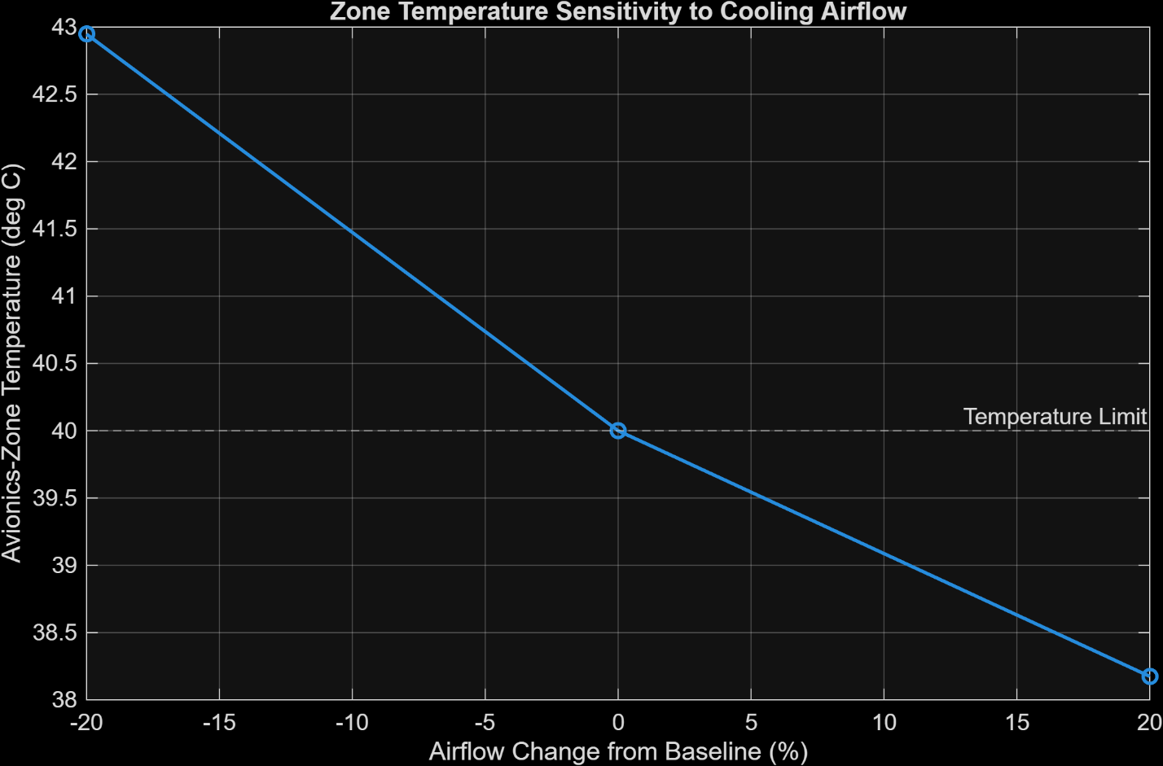
Figure 2. Effect of avionics thermal-load variation on ECS airflow, fan-power, and heat-exchanger requirements.
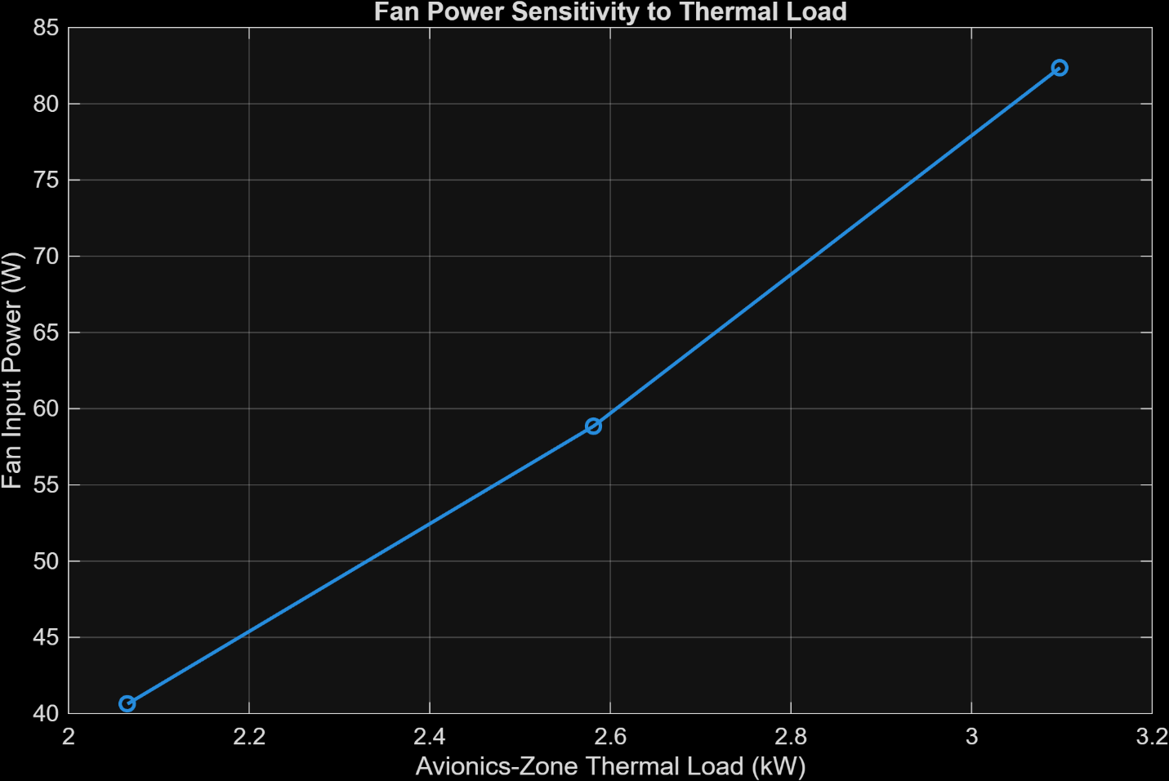
Figure 3. Effect of avionics thermal load on required ECS fan input power.

External Cooling-Air Temperature Sensitivity
External cooling-air inlet temperature was varied from $-{15}^{∘}\text{C}$ to ${25}^{∘}\text{C}$ while maintaining the baseline thermal requirement and airflow. At $-{15}^{∘}\text{C}$, the required heat-exchanger effectiveness was approximately $ε=0.277$ At ${15}^{∘}\text{C},$ the required effectiveness increased to approximately $ε=0.605$
At an external inlet temperature of (25^\circ\text{C}), $\boxed{ε_{\text{required}}=1}$ for the specified 25°C supply-air target.
This represents the thermodynamic limiting condition of the selected architecture. A finite real heat exchanger cannot achieve an effectiveness of exactly unity, so the specified supply condition cannot practically be maintained as the external cooling-air inlet approaches the desired supply-air temperature.
External-air temperature is therefore a major environmental driver of ECS thermal feasibility.
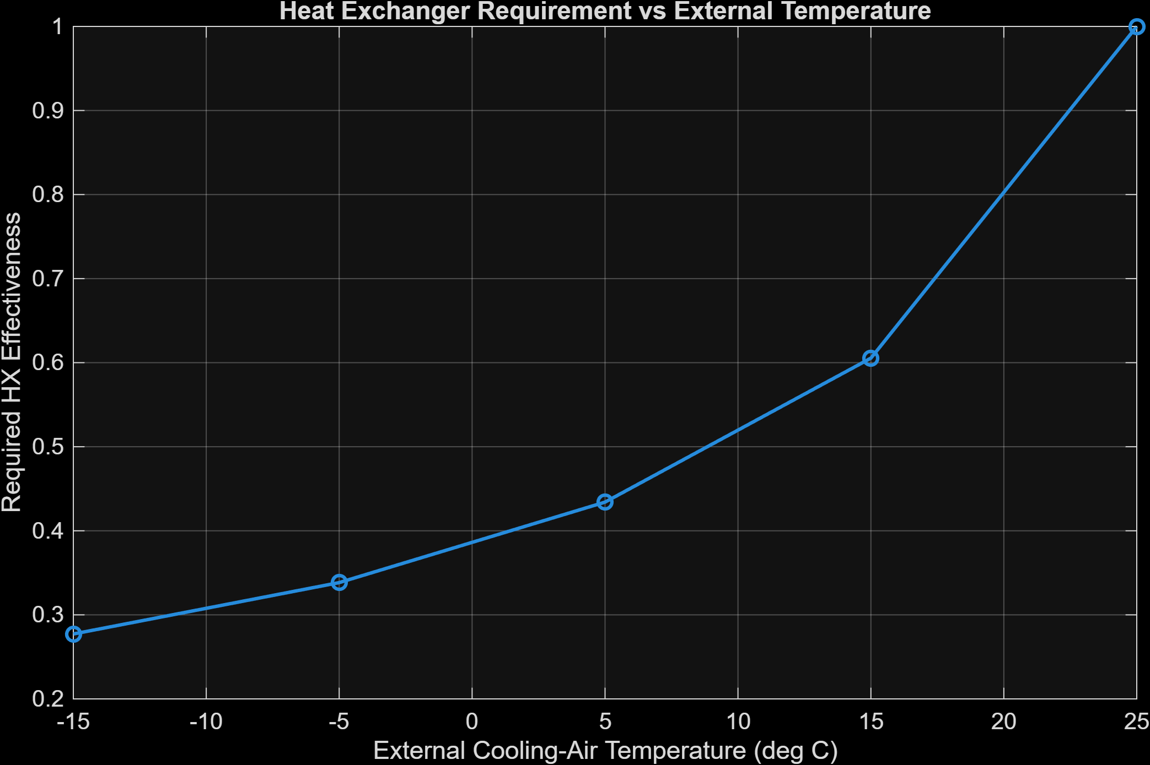
Figure 4. Effect of heat-exchanger thermal conductance on avionics-zone temperature and thermal margin.

Recirculation-Airflow Sensitivity
The physical heat exchanger was held at the refined baseline conductance while recirculation airflow was varied by ±20%.
At 20% below baseline airflow, the predicted avionics-zone temperature increased to $\boxed{{42.95}^{∘}\text{C}}$ which exceeds the 40°C design limit.
At baseline airflow, the compartment operates at exactly ${40.0}^{∘}\text{C}$
At 20% above baseline airflow, the predicted zone temperature decreases to $\boxed{{38.17}^{∘}\text{C}}$
providing approximately 1.83°C of positive thermal margin.
However, this increased airflow also raises fan input power from the baseline 58.86 W to approximately $82.37 \text{W}$
The airflow study therefore demonstrates a direct thermal–aerodynamic tradeoff: additional airflow improves compartment-temperature margin but increases pressure losses and fan-power requirements.

Duct-Diameter Sensitivity
Duct diameter was varied between 150 mm and 200 mm while maintaining baseline volumetric airflow.
For a 150 mm duct, the modeled velocity is approximately $12.20 \text{m/s}$ and total pressure loss is approximately $222.1 \text{Pa}$ requiring approximately $79.8 \text{W}$ of fan input power.
Increasing the duct diameter to 200 mm decreases velocity to approximately $6.86 \text{m/s}$
and total pressure loss to $136.5 \text{Pa}$ reducing fan input power to approximately $49.0 \text{W}$
The larger duct therefore reduces fan power substantially, although packaging volume would increase.
The normalized fan-power sensitivity to duct diameter near the baseline is approximately $\boxed{S_{D}=-1.83}$ indicating that duct diameter is the strongest normalized fan-power design variable among those evaluated.

Heat-Exchanger Pressure-Drop Sensitivity
The assumed heat-exchanger aerodynamic pressure loss was varied from 50 Pa to 200 Pa.
Across this range, fan input power increased from approximately $40.9 \text{W}$ to $94.8 \text{W}$ while the required thermal conductance changed only modestly.
This demonstrates that heat-exchanger pressure drop acts primarily as an aerodynamic and electrical-power penalty rather than as a dominant thermal-sizing parameter.
The approximate normalized fan-power sensitivity to heat-exchanger pressure drop near the baseline is $\boxed{S_{ΔP_{HX}}=+0.61}$
Although this normalized sensitivity is lower than the duct-diameter sensitivity, heat-exchanger pressure drop remains an important component-selection uncertainty because its absolute range may be large.

Fan-Efficiency Sensitivity
Fan efficiency was varied from 40% to 80%.
At 40% efficiency, the required fan input power is approximately $88.3 \text{W}$ whereas at 80% efficiency it falls to approximately $44.1 \text{W}$
The required heat-exchanger conductance changes only slightly over this range.
Fan efficiency therefore primarily affects electrical power consumption rather than the fundamental thermal sizing of the system.
The normalized fan-power sensitivity to efficiency is approximately $\boxed{S_{η_{f}}=-1.03}$

Heat-Exchanger Thermal-Performance Sensitivity
Heat-exchanger conductance was varied between 80% and 120% of the refined baseline value.
A 10% reduction in heat-exchanger conductance increases the predicted zone temperature to $\boxed{{43.58}^{∘}\text{C}}$ which exceeds the thermal requirement.
A 20% reduction increases the predicted temperature further to $\boxed{{48.06}^{∘}\text{C}}$
Conversely, increasing heat-exchanger conductance by 10% reduces the zone temperature to approximately ${37.07}^{∘}\text{C}$ and provides approximately 2.93°C of thermal margin.
The local zone-temperature sensitivities around the baseline were estimated as $\frac{dT_{zone}}{d(\%in)}≈-0.119℃/\%$ for recirculation airflow and $\frac{dT_{\text{zone}}}{d(\%U)}≈-0.325℃/\%$ for heat-exchanger conductance.
Therefore, near the baseline, zone temperature is approximately 2.73 times more sensitive to percentage changes in UA than to airflow.
This identifies heat-exchanger thermal capability as the dominant controllable thermal-robustness variable in the current design.
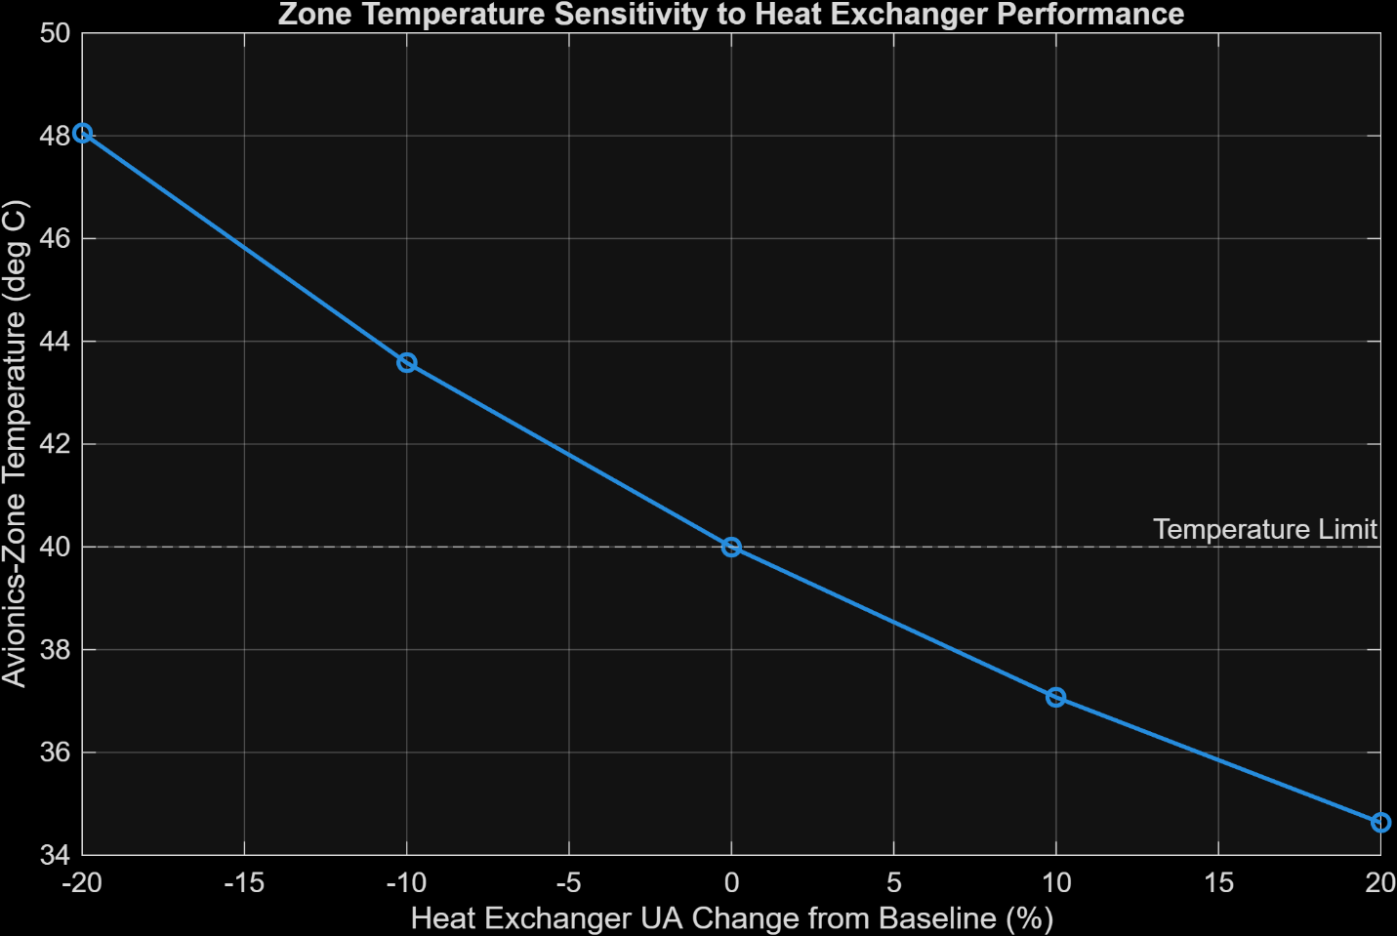
Figure 5. Effect of heat-exchanger thermal conductance on avionics-zone temperature and thermal margin.

Overall Sensitivity Findings
The sensitivity analysis identifies separate dominant variables for different ECS objectives.
Heat-exchanger thermal conductance is the strongest controllable parameter affecting compartment thermal robustness.
External cooling-air temperature is a major environmental constraint and can eventually impose a fundamental thermodynamic limit on the selected air-to-air cooling architecture.
Duct diameter has the strongest normalized influence on fan input power near the baseline.
Fan efficiency strongly influences electrical power demand but has relatively little effect on the required heat-exchanger thermal capability.
Heat-exchanger pressure drop remains a major aerodynamic uncertainty because it can substantially increase the required fan operating pressure and input power.
The sensitivity results confirm that the original baseline configuration is not sufficiently robust because its nominal operating point lies exactly at the 40°C compartment-temperature limit. The next design stage should therefore introduce positive thermal margin while balancing heat-exchanger size, duct packaging, fan power, and aerodynamic resistance.

Robust Design Selection and Independent Validation
The baseline sensitivity analysis demonstrated that the initial ECS configuration satisfied the nominal thermal requirement but provided no thermal reserve. A subsequent parametric design study was therefore conducted to identify a more robust configuration.
Two explicit engineering design criteria were imposed. Under the nominal operating condition, the avionics-zone temperature was required to remain at or below $T_{\text{zone,nominal}}≤{38}^{∘}\text{C}$ providing at least 2°C of nominal reserve relative to the 40°C maximum-temperature requirement.
A combined robustness condition was also introduced in which the developed avionics thermal load was increased by 10% while the selected heat-exchanger conductance was simultaneously reduced by 10%. Under this stressed condition, the avionics-zone temperature was required to remain below $T_{\text{zone,worst}}≤{40}^{∘}\text{C}$
These margins are project-level engineering design criteria rather than certification requirements.
A total of 50 candidate configurations were evaluated by varying duct diameter, recirculation airflow, and heat-exchanger thermal conductance. The investigated values were $D=0.175, 0.200 \text{m}$ recirculation airflow between 100% and 120% of the original baseline value, and heat-exchanger conductance between 110% and 130% of the refined baseline requirement.
Of the 50 configurations evaluated, $\boxed{20}$ satisfied both the nominal and combined robustness requirements.
Within the investigated design space, each feasible 200 mm duct configuration provided lower aerodynamic resistance and fan power than its corresponding 175 mm configuration at the same airflow and heat-exchanger conductance. The 200 mm duct was therefore preferred, subject to the assumption that the additional packaging volume is acceptable.
A balanced robust design candidate was selected with $\boxed{D=0.200 \text{m}}$, $\boxed{\dot{m}=0.18838 \text{kg/s}}$ and $\boxed{UA=102.22 \text{W/K}}$ corresponding to a 14.29% increase in duct diameter, a 10% increase in recirculation airflow, and a 25% increase in heat-exchanger conductance relative to the original refined baseline.
Table 9. Comparison of the original baseline and selected robust ECS configurations.
Design Parameter | Baseline | Selected Design | Change
Duct diameter | 0.175 m | 0.200 m | +14.29%
Recirculation mass flow | 0.17125 kg/s | 0.18838 kg/s | +10%
HX thermal conductance, U A | 81.77 W/K | 102.22 W/K | +25%
System pressure loss | 163.86 Pa | 143.96 Pa | −12.15%
Fan input power | 58.86 W | 56.89 W | −3.35%

The selected configuration is not claimed to be a global optimum because heat-exchanger mass, volume, cost, detailed geometry, and hardware-specific pressure-drop data are not available. It is instead identified as a robust design candidate selected from the defined engineering trade space.
Despite the increased recirculation airflow, the larger duct reduces the modeled system pressure loss from $163.86 \text{Pa}$ To $\boxed{143.96 \text{Pa}}$ representing a reduction of approximately $\boxed{12.15}$
The corresponding fan input power decreases from 58.86 W to $\boxed{56.88 \text{W}}$ or approximately $\boxed{3.36\%}$ below the original baseline requirement.
The selected configuration therefore improves thermal robustness without introducing an additional fan-power penalty.
An independent calculation was subsequently performed outside the parametric design sweep to verify the selected configuration.
The recalculated duct velocity is $7.55 \text{m/s}$ with $Re=6.41×{10}^{4}$ and $Ma=0.0215$ confirming turbulent internal flow and a comfortably low Mach number.
The independently calculated fan temperature rise is approximately ${0.300}^{∘}\text{C}$ and the selected heat exchanger has a nominal counterflow effectiveness of $ε=0.3717$
At full selected cooling capability, the nominal heat-exchanger outlet temperature is approximately $T_{\text{supply}}={18.76}^{∘}\text{C}$ and the resulting avionics-zone temperature is $\boxed{T_{\text{zone,nominal}}={32.40}^{∘}\text{C}}$
This provides approximately 5.61°C of margin relative to the 38°C nominal design target and 7.61°C relative to the 40°C maximum-temperature requirement.
The large nominal margin indicates that the selected thermal hardware need not operate at maximum cooling capability continuously. In a practical implementation, fan-speed control, heat-exchanger bypass, or external-airflow modulation could be used to regulate cooling output under nominal conditions.
For the combined robustness case, the thermal load was increased to 110% of baseline while only 90% of the selected heat-exchanger conductance was retained. The effective heat-exchanger conductance in this condition is $UA_{\text{worst}}=92.00 \text{W/K}$ with an effectiveness of approximately $ε_{\text{worst}}=0.3453$
The corresponding predicted supply temperature is ${24.21}^{∘}\text{C}$ and the avionics-zone temperature is $\boxed{T_{\text{zone,worst}}={39.21}^{∘}\text{C}}$ providing a remaining margin of $\boxed{{0.795}^{∘}\text{C}}$ to the 40°C maximum-temperature requirement.
The independent validation produced a heat-exchanger energy-balance error of approximately $1.7×{10}^{-14}\%$ and zero numerical zone-temperature closure error. The nominal thermal target, combined robustness condition, turbulent-flow requirement, low-Mach assumption, and energy-balance criterion all passed independently.
The selected configuration is therefore accepted as the current robust ECS design candidate for subsequent validation and final engineering assessment.

Off-Design and Operational Performance
Following selection of the robust ECS configuration, the design was evaluated under off-design operating conditions while keeping the selected physical hardware fixed. The purpose of this analysis was to determine the useful thermal operating envelope of the system rather than resizing the ECS independently for each condition.
The selected configuration retained a 200 mm recirculation duct, a nominal hot-side mass flow of 0.18838 kg/s, and a heat-exchanger conductance of 102.22 W/K.

External Cooling-Air Temperature Envelope
The external cooling-air temperature was varied while maintaining the baseline avionics thermal load and selected-design operating point.
At an external-air temperature of $-{15}^{∘}\text{C}$ the predicted avionics-zone temperature is approximately ${22.20}^{∘}\text{C}$
At the original design environment near $-{4.8}^{∘}\text{C}$ the selected configuration produces an avionics-zone temperature of approximately ${32.4}^{∘}\text{C}$
At an external-air temperature of $0^{∘}\text{C}$ the predicted zone temperature increases to approximately ${37.20}^{∘}\text{C}$ and the system continues to satisfy the 40°C maximum-temperature requirement.
The analytically calculated maximum external cooling-air temperature at the baseline avionics heat load is $\boxed{T_{\text{external,max}}={2.805}^{∘}\text{C}}$
Above this condition, the fixed selected configuration operating at the modeled flow condition can no longer maintain the avionics zone below 40°C.
For example, at an external cooling-air temperature of 5°C, the predicted zone temperature rises to approximately ${42.20}^{∘}\text{C}$ and the thermal requirement is violated.
The selected air-to-air cooling architecture therefore has a clearly defined environmental operating limit, which depends strongly on avionics thermal load.

Fixed-Hardware Thermal-Load Envelope
The selected hardware was subsequently evaluated at thermal loads ranging from 80% to 120% of the developed baseline load while maintaining the original external cooling-air condition of approximately $-{4.8}^{∘}\text{C}.$
At 80% of baseline load, the predicted zone temperature is approximately ${25.06}^{∘}\text{C}$
At the baseline thermal load, $T_{\text{zone}}={32.40}^{∘}\text{C}$
At 110% of baseline load, $T_{\text{zone}}={36.06}^{∘}\text{C}$ and at 120% of baseline load, $T_{\text{zone}}={39.73}^{∘}\text{C}$ which remains slightly below the 40°C limit.
The maximum allowable avionics-zone thermal load at the baseline external condition was calculated as $\boxed{{\dot{Q}}_{\text{load,max}}=3116.7 \text{W}}$ corresponding to $\boxed{1.207,{\dot{Q}}_{\text{load,baseline}}}$ or approximately $\boxed{20.73\%}$ additional thermal-load capacity before reaching the 40°C zone-temperature limit.
This represents a significant improvement over the original minimally sized baseline configuration, which provided essentially no thermal-load reserve.

Combined Thermal-Load and Environmental Operating Envelope
Thermal load and external cooling-air temperature were then varied simultaneously to characterize the combined operating envelope of the selected ECS.
A total of 28 discrete combinations were evaluated using four thermal-load levels and seven external-temperature conditions.
Of the 28 investigated operating points, $\boxed{16}$ satisfied the 40°C avionics-zone temperature requirement, while $\boxed{12}$ exceeded the requirement.
The limiting external-air temperature decreases as avionics thermal load increases.
Representative operating-boundary values are $T_{\text{external,max}}{10.14}^{∘}\text{C}$ at 80% of baseline thermal load, $T_{\text{external,max}}{2.80}^{∘}\text{C}$ at the baseline thermal load, $T_{\text{external,max}}-{0.86}^{∘}\text{C}$ at 110% of baseline load, and $T_{\text{external,max}}-{4.53}^{∘}\text{C}$ at 120% of baseline load.
A continuous thermal operating-boundary curve was generated from the analytical model. Operating conditions below this boundary satisfy the 40°C avionics-zone requirement, whereas combinations above the boundary exceed the permissible temperature.
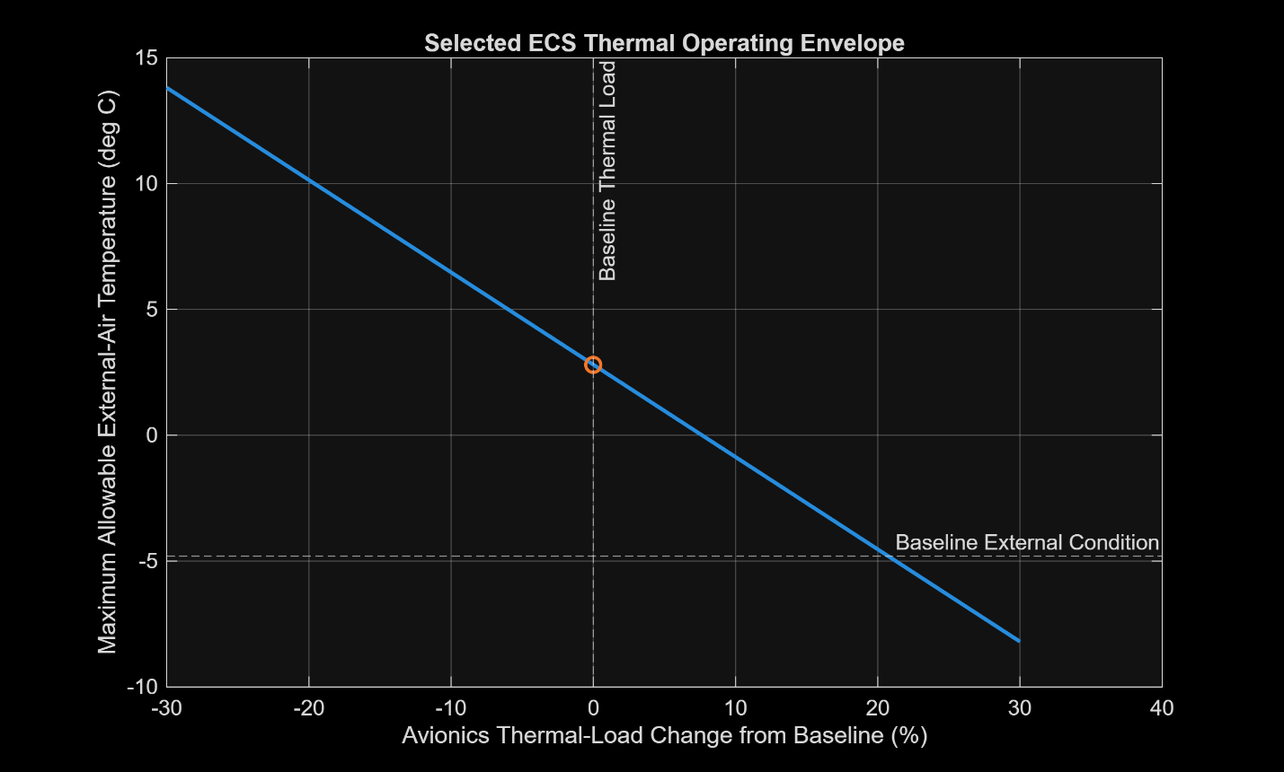
Figure 6. Thermal operating envelope of the selected ECS showing the allowable combinations of avionics thermal load and external cooling-air temperature for the 40°C zone-temperature limit.
The operating-envelope analysis demonstrates the coupled nature of thermal load and environmental heat-sink temperature. Increasing avionics heat generation reduces the external-air temperature at which the air-to-air cooling architecture can successfully reject the required heat.

Nominal Cooling Modulation
The selected robust design intentionally contains greater thermal capability than is required at the nominal operating condition. When operated at its full modeled capability, the selected configuration predicts a nominal avionics-zone temperature of approximately ${32.40}^{∘}\text{C}$ which is substantially below the 38°C nominal design target.
A cooling-modulation calculation was therefore performed to determine the effective heat-exchanger capability required to maintain the zone at exactly $\boxed{{38}^{∘}\text{C}}$ under the baseline environmental and thermal conditions.
At the selected recirculation airflow, the required supply-air temperature is $\boxed{T_{\text{supply}}={24.364}^{∘}\text{C}}$
The corresponding required heat-exchanger effectiveness is $\boxed{ε_{\text{required}}=0.3234}$ and the required effective thermal conductance is $\boxed{UA_{\text{effective}}=83.95 \text{W/K}}$
Compared with the selected physical heat-exchanger conductance of $102.22 \text{W/K}$ the nominal condition requires approximately $\boxed{82.13\%}$ of the available thermal capability.
The remaining effective conductance headroom is therefore approximately$\boxed{17.87\%}$
This excess capability is deliberately retained to provide off-design robustness rather than being required continuously during nominal operation.
A practical ECS could regulate cooling through heat-exchanger bypass, external cooling-air modulation, variable recirculation airflow, or a combination of these mechanisms. The present system-level model does not translate the calculated effective-UA reduction directly into a valve position, bypass fraction, or fan command because these relationships depend on component-specific hardware characteristics.

Operational Assessment
The off-design analysis demonstrates that the selected ECS configuration provides substantially greater robustness than the original baseline while retaining a clearly quantifiable operating envelope.
At the original external design condition, the selected configuration can accommodate approximately 20.7% additional avionics thermal load before reaching the maximum compartment temperature.
At baseline thermal load, the maximum allowable external cooling-air temperature is approximately 2.8°C.
The interaction between these quantities was captured in a continuous thermal operating-envelope curve, providing a direct system-level representation of safe and unsafe combinations of thermal load and environmental temperature.
The selected design also contains sufficient nominal thermal headroom to permit active cooling modulation rather than continuous operation at maximum heat-exchanger capability.
These off-design results strengthen the selected configuration by demonstrating not only nominal feasibility but also load reserve, environmental limitations, and a practical operational strategy.
The off-design analysis assumes the selected fan operating point, airflow ratio, and baseline thermophysical properties remain fixed while thermal load and external temperature are varied. Component-specific variable-speed fan behavior, detailed heat-exchanger performance maps, and temperature-dependent property variations are outside the present preliminary-design scope and represent potential future refinements.

CFD Validation of the Selected Duct Network
A three-dimensional CFD analysis was performed in SOLIDWORKS Flow Simulation to validate the pressure-loss prediction of the selected ECS recirculation duct network.
The CFD model represented the selected 200 mm internal-diameter duct geometry with five smooth 90° bends. Each bend used a centerline radius of $R=0.300\text{ m}$ corresponding to $\frac{R}{D}=1.5$
The final CFD geometry included a downstream outlet extension to provide approximately five duct diameters of straight recovery length after the final elbow. This was added after an initial solution produced a warning indicating that a vortex crossed the outlet pressure boundary.
The CFD analysis therefore excluded the preliminary 100 Pa heat-exchanger pressure-drop assumption and focused only on the duct and elbow network.

CFD Boundary Conditions
The recirculating-air inlet mass flow was prescribed as $\dot{m}=0.18838\text{ kg/s}$ which corresponds to the selected robust ECS design.
The outlet static pressure was specified as $P_{\text{out}}=69.7\text{ kPa}$
The nominal internal-flow temperature was approximately $T=305.65\text{ K}$ and the duct-wall roughness was specified as $ε=1.5×{10}^{-6}\text{ m}$ to remain consistent with the analytical model.
The duct walls were treated as adiabatic, and the analysis was steady-state with both laminar and turbulent flow permitted by the solver.

Mesh-Convergence Study
A controlled manual-mesh study was performed to assess numerical sensitivity of the predicted pressure drop.
The three principal refinement cases were: $40×8×104$, $60×12×156$, $80×16×208$ followed by a final refinement of $100×20×260$
The corresponding solver cell counts increased to approximately $9,994$ , $31,248$, $71,347$ and $136,025$ cells, respectively.
The averaged CFD pressure-drop predictions were approximately $26.20\text{ Pa}$, $28.17\text{ Pa}$, $27.52\text{ Pa}$ and $26.83\text{ Pa}$ for the four progressively refined meshes.
The two finest meshes differed by approximately $2.57$% or $0.69\text{ Pa}$ indicating that the pressure-drop solution had approached an adequately stable range for the present preliminary design study.
Table 10. CFD mesh-refinement study for the selected ECS duct network.
Mesh Case | Nominal Mesh Definition | Solver Cells | Pressure Drop (Pa)
1 | 40 x 8 x 104 | 9,994 | 26.20
2 | 60 x 12 x 156 | 31,248 | 28.17
3 | 80 x 16 x 208 | 71,347 | 27.52
4 | 100 x 20 x 260 | 136,025 | 26.83

The finest-mesh CFD value was therefore adopted as $\boxed{ΔP_{\text{CFD}}=26.83\text{ Pa}}$
The final solution converged without solver warnings.

CFD-Matched Analytical Model
To perform a fair comparison, the one-dimensional analytical pressure-loss model was updated to match the exact CFD geometry.
After the outlet recovery extension and replacement of the five sharp corners by 300 mm-radius quarter-circle bends, the resulting centerline length was $\boxed{L_{\text{centerline}}=4.6562\text{ m}}$
At the selected mass flow and 200 mm duct diameter, the analytical flow quantities were $V=7.547\text{ m/s}$, $Re=64,130$ and $f=0.01968$ using the same roughness basis as the original system model.
The predicted distributed friction loss was $ΔP_{\text{major}}=10.37\text{ Pa}$
The preliminary analytical model used a loss coefficient of $K_{\text{elbow}}=0.30$ for each of the five bends, producing an elbow-loss contribution of $ΔP_{\text{elbows}}=33.94\text{ Pa}$
The geometry-matched analytical pressure drop was therefore $\boxed{ΔP_{\text{1D}}=44.30\text{ Pa}}$

Analytical-to-CFD Comparison
The difference between the geometry-matched analytical result and the finest-mesh CFD result is $44.30-26.83\boxed{17.47\text{ Pa}}$
Relative to the CFD result, the analytical model overpredicts pressure loss by $\boxed{65.13\%}$
Equivalently, the CFD result is approximately $\boxed{39.44\%}$ below the analytical prediction.
The discrepancy is primarily associated with the preliminary elbow-loss assumption rather than the distributed Darcy friction term.
Subtracting the analytical major-loss contribution from the CFD pressure drop gives an effective CFD bend-loss contribution of $ΔP_{\text{bend,CFD}}26.83-10.37\boxed{16.46\text{ Pa}}$
Using $ΔP_{\text{bend}}NK\frac{ρV^{2}}{2}$ the CFD-derived effective elbow loss coefficient becomes $\boxed{K_{\text{elbow,eff}}=0.146}$ compared with the original assumed value of $K_{\text{elbow}}=0.300$
This represents an effective reduction of approximately $\boxed{51.49\%}$ for the smooth $R/D=1.5$ elbow geometry used in the CFD model.
Table 11. Comparison of geometry-matched analytical and CFD pressure-loss predictions for the selected duct network.
Validation Metric | Analytical Model | CFD / CFD-Derived
Duct-network pressure drop | 44.30 Pa | 26.83 Pa
Distributed/major loss | 10.37 Pa | -
Bend-loss contribution | 33.94 Pa | 16.46 Pa
Effective elbow K | 0.300 | 0.146
Difference in pressure drop | - | 17.47 Pa
Analytical overprediction relative to CFD | - | 65.13%
CFD below analytical prediction | - | 39.44%
Reduction in effective elbow K | - | 51.49%

Engineering Interpretation
The CFD results indicate that the preliminary one-dimensional duct-loss model was conservative for the selected smooth long-radius geometry.
The original analytical framework remains useful for early system sizing because it provides a simple and intentionally conservative estimate of fan pressure requirement. However, the three-dimensional CFD model demonstrates that the actual bend losses for the idealized smooth geometry are significantly lower than implied by the preliminary (K=0.30) assumption.
For this reason, the original analytical coefficient is retained as the conservative preliminary sizing basis, while the CFD-derived value is treated as a refinement and validation result rather than a wholesale replacement of the analytical design assumption.
This preserves fan-sizing margin while demonstrating that the selected geometry has lower aerodynamic losses than initially estimated.

CFD Flow-Field Observations
Static-pressure contours show an overall pressure decrease through the duct network, with local pressure redistribution through each curved section.
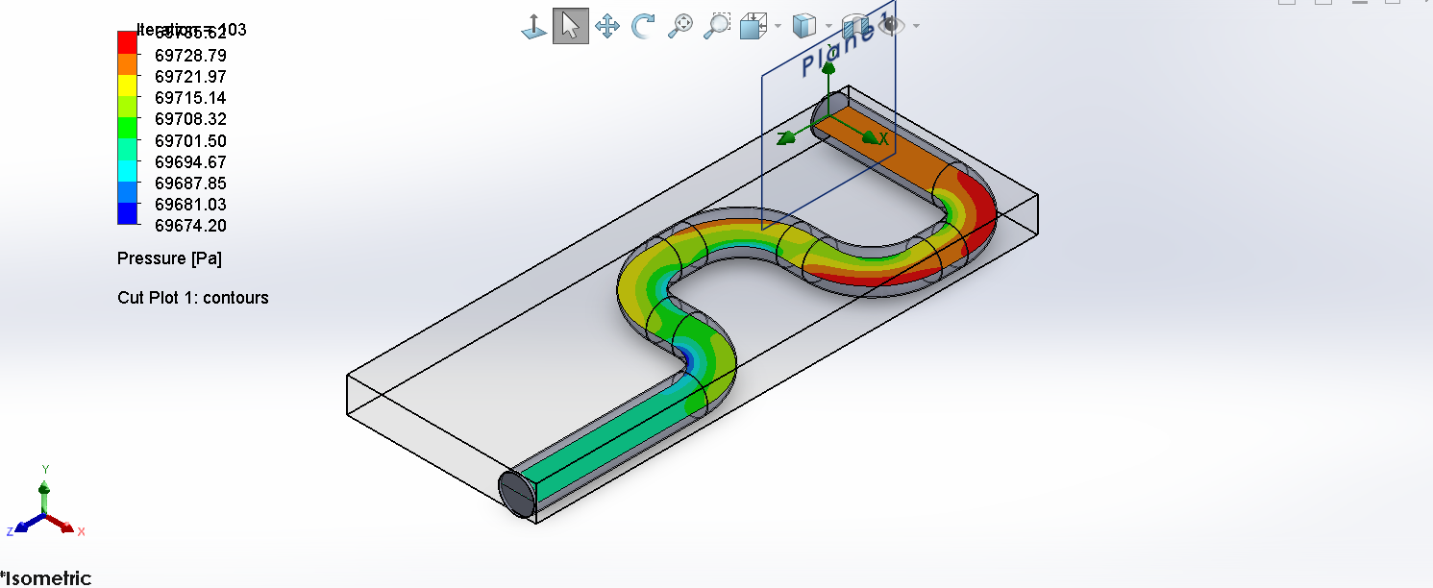
Figure 7. CFD static-pressure distribution through the selected ECS recirculation duct network.
Velocity-magnitude contours show that the flow is comparatively uniform in straight duct sections but becomes redistributed across the cross-section as it passes through the elbows.
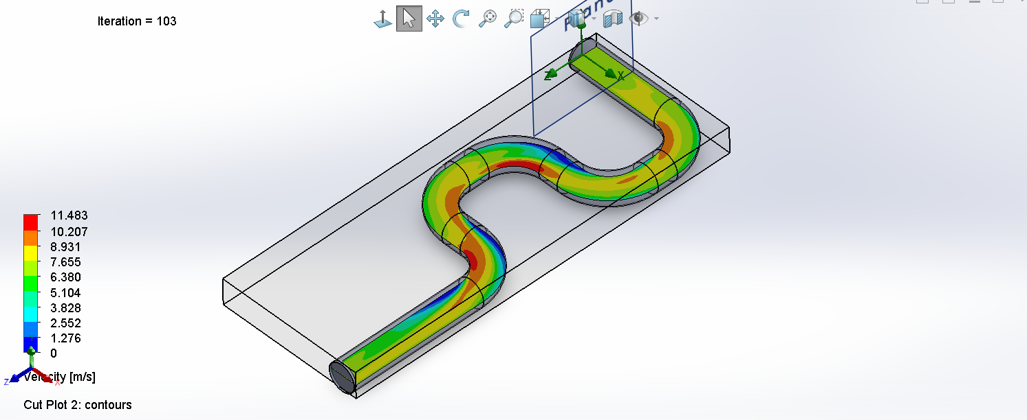
Figure 8. CFD velocity-magnitude distribution showing flow redistribution through the bends of the selected ECS duct network.
Flow trajectories further demonstrate secondary-flow development and locally accelerated regions within the bends.
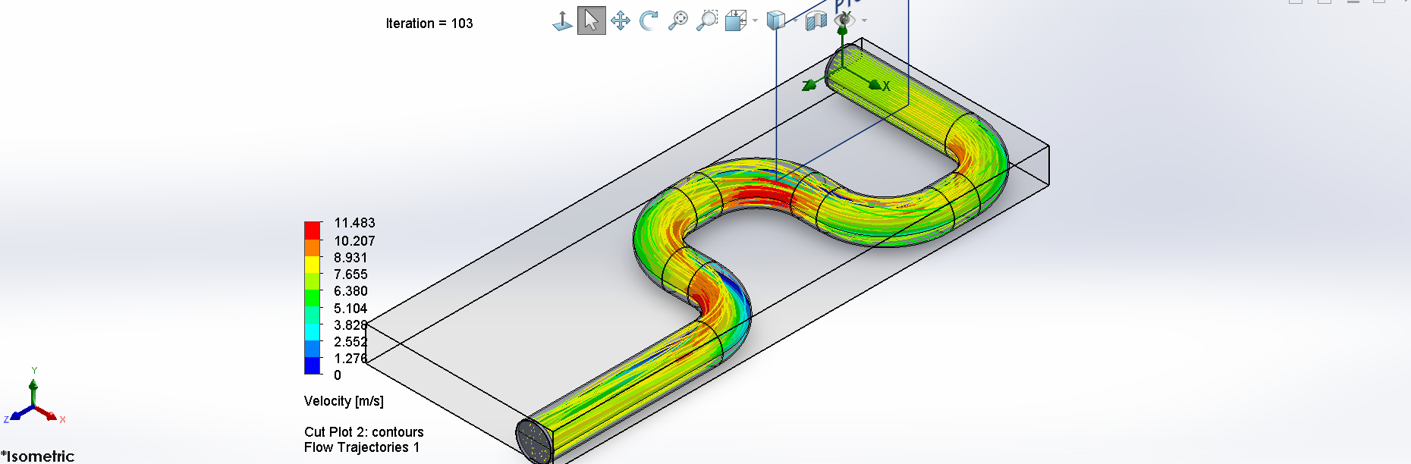
Figure 9. CFD flow trajectories through the selected ECS duct network, illustrating three-dimensional flow development through successive bends.
The centerline velocity-vector plot confirms that the three-dimensional flow structure through the elbows is more complex than the one-dimensional representation, supporting the use of CFD as a validation tool for the preliminary pressure-loss model.
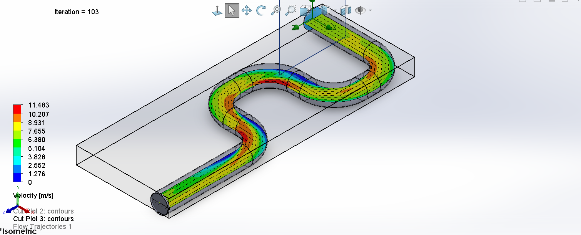
Figure 10. Centerline CFD velocity contour and vector field showing local flow acceleration and directional changes through the duct bends.
Overall, the CFD study provides an independent numerical check on the selected duct network, verifies that the one-dimensional model is conservative, quantifies the effective bend-loss reduction for the selected geometry, and strengthens confidence in the aerodynamic feasibility of the selected ECS design.

Final Design Validation and Design Freeze
The selected ECS configuration was subjected to a final integrated validation after completion of the analytical, parametric, off-design, and CFD studies.
The final selected design is defined by $\boxed{D=0.200 \text{m}}$ , $\boxed{\dot{m}=0.18838 \text{kg/s}}$ and $\boxed{UA=102.22 \text{W/K}}$
The corresponding volumetric recirculation flow is approximately $\boxed{\dot{V}=0.2371 {\text{m}}^{3}/\text{s}}$
The conservative analytical fan-sizing pressure requirement is $\boxed{ΔP_{\text{design}}=143.96 \text{Pa}}$ whereas the CFD-informed system pressure estimate is approximately $\boxed{ΔP_{\text{CFD-informed}}=126.83 \text{Pa}}$
The conservative design basis therefore provides approximately $\boxed{11.9\%}$ pressure-loss margin relative to the CFD-informed estimate.
At the assumed 60% fan efficiency, the conservative fan input-power requirement is $\boxed{56.89 \text{W}}$ compared with a CFD-informed estimate of approximately $\boxed{50.12 \text{W}}$
Table 12. Final selected ECS design parameters and validated performance metrics.
Parameter | Final Value | Unit
Duct diameter | 0.200 | m
Recirculation mass flow | 0.18838 | kg/s
Volumetric flow | 0.23709 | m³/s
Selected HX U A | 102.22 | W/K
Conservative system pressure loss | 143.96 | Pa
CFD-informed system pressure loss | 126.83 | Pa
Fan efficiency | 60 | %
Conservative fan input power | 56.89 | W
CFD-informed fan input power | 50.12 | W
Nominal zone temperature | 32.395 | °C
Worst-case zone temperature | 39.205 | °C
Worst-case thermal margin | 0.795 | °C
Maximum thermal load | 3116.7 | W
Maximum external-air temperature | 2.805
CFD duct pressure drop | 26.83 | Pa
CFD-derived effective elbow K | 0.146 | -
Final design status | PASS | -

The final design therefore retains aerodynamic margin without requiring an excessive fan-power penalty.
Under the nominal selected-design condition, the predicted avionics-zone temperature is $\boxed{{32.40}^{∘}\text{C}}$ and under the combined robustness condition of 10% increased thermal load with 10% reduction in effective heat-exchanger conductance, the predicted zone temperature is $\boxed{{39.21}^{∘}\text{C}}$
This leaves a positive worst-case thermal margin of approximately $\boxed{{0.795}^{∘}\text{C}}$ relative to the 40°C maximum-temperature requirement.
At the original external design condition, the selected ECS can accommodate a maximum avionics-zone thermal load of approximately $\boxed{3116.7 \text{W}}$ corresponding to approximately $\boxed{20.7\%}$ additional thermal-load capacity above the developed baseline.
At baseline thermal load, the maximum permissible external cooling-air temperature is approximately $\boxed{{2.805}^{∘}\text{C}}$ before the 40°C zone-temperature limit is reached.
The CFD study of the selected duct network produced a finest-mesh duct pressure drop of $\boxed{26.83 \text{Pa}}$ and a CFD-derived effective elbow loss coefficient of approximately $\boxed{K_{\text{eff}}=0.146}$
The corresponding geometry-matched analytical model predicted 44.30 Pa, demonstrating that the preliminary one-dimensional pressure-loss model is conservative for the idealized smooth long-radius duct geometry.
The two finest CFD meshes differed in predicted pressure drop by approximately $\boxed{2.57\%}$
which was accepted as adequate mesh stability for the present preliminary engineering study.
A final integrated pass/fail assessment was then performed.
The nominal zone-temperature requirement passed.
The combined worst-case zone-temperature requirement passed.
Positive worst-case thermal margin was retained.
The selected duct-flow Reynolds number remained in the turbulent regime.
The Mach number remained well below the low-speed threshold of 0.3.
The independent thermal-energy balance satisfied the 1% acceptance criterion.
The CFD two-finest-mesh pressure-drop variation remained below 3%.
The conservative analytical fan-sizing pressure remained greater than the CFD-informed pressure requirement.
Positive thermal-load reserve was retained.
The external-temperature operating envelope remained above the original design environmental condition.
All final validation criteria therefore passed.
The final design status is $\boxed{\text{PASS}}$
Table 13. Final integrated validation matrix for the selected ECS design.
Validation Criterion | Acceptance Requirement | Result
Nominal zone temperature | T_{zone}≤ 38̊ C | PASS
Worst-case zone temperature | T_{zone}≤̊ C | PASS
Worst-case thermal margin | > 0̊ C | PASS
Flow regime | Turbulent | PASS
Low-Mach assumption | Ma < 0.3 | PASS
Energy-balance error | < 1% | PASS
CFD mesh variation | < 3% | PASS — 2.57%
Fan sizing | Analytical design pressure ≥ CFD-informed pressure | PASS
Thermal-load reserve | Positive | PASS
Environmental operating envelope | Above baseline design condition | PASS
Overall design status | All criteria satisfied | PASS

The configuration is therefore frozen as the final selected preliminary ECS design for this project. Remaining work is limited to report organization, figure integration, formatting, reference cleanup, and final presentation of the completed engineering results.

Conclusions

This project developed a preliminary aircraft environmental control system for cooling an avionics/electronics equipment compartment using a closed recirculating-air loop and a separate external cooling-air stream through an air-to-air heat exchanger.
The developed net compartment thermal load was $2581.6 \text{W}$ and the initial baseline design required approximately $0.1713 \text{kg/s}$ of recirculation airflow to maintain a 25°C supply condition and a 40°C avionics-zone temperature.
The baseline system was shown to be physically consistent through thermal-energy closure, pressure-loop closure, Reynolds-number evaluation, and low-Mach-number verification. However, the baseline operated exactly at the 40°C maximum zone-temperature requirement and therefore contained no meaningful thermal reserve.
Sensitivity analysis identified heat-exchanger thermal conductance as the strongest controllable parameter affecting thermal robustness. Near the baseline, the zone-temperature sensitivity to percentage changes in (UA) was approximately 2.73 times greater than the corresponding sensitivity to percentage changes in airflow. Duct diameter was identified as the strongest normalized fan-power variable, while heat-exchanger pressure drop and fan efficiency were also significant aerodynamic and electrical design parameters.
A 50-case robust-design sweep was used to move beyond the minimally sized baseline. The selected configuration used $\boxed{D=0.200 \text{m}}$, $\boxed{\dot{m}=0.18838 \text{kg/s}}$ and $\boxed{UA=102.22 \text{W/K}}$
The selected design improved thermal robustness while simultaneously reducing the conservative modeled system pressure loss by approximately 12.2% relative to the original baseline. The corresponding fan input-power requirement decreased slightly to approximately $56.9 \text{W}$ despite the 10% increase in recirculation airflow.
Independent recalculation of the selected design predicted a nominal avionics-zone temperature of approximately ${32.4}^{∘}\text{C}$ and a combined stressed-condition temperature of ${39.21}^{∘}\text{C}$ when thermal load was increased by 10% and effective heat-exchanger conductance was reduced by 10%. The selected configuration therefore retained approximately ${0.795}^{∘}\text{C}$ of margin to the 40°C maximum-temperature requirement in the stressed condition.
Off-design analysis showed that the selected design could tolerate approximately 20.7% additional avionics thermal load at the baseline external condition before reaching the maximum zone temperature. The allowable external cooling-air temperature at baseline thermal load was approximately ${2.81}^{∘}\text{C}$ and a continuous operating-envelope relationship was developed to quantify the interaction between avionics heat generation and environmental heat-sink temperature.
The selected duct network was subsequently evaluated using three-dimensional CFD. A controlled mesh-refinement study increased the solver model to approximately 136,000 cells, with the two finest meshes differing in predicted pressure drop by approximately 2.57%.
The finest-mesh CFD prediction for the duct and elbow network was $\boxed{26.83 \text{Pa}}$ while the geometry-matched one-dimensional model predicted $44.30 \text{Pa}$
The analytical model therefore provided a conservative estimate for the idealized smooth long-radius geometry. The CFD-derived effective elbow coefficient was approximately $K_{\text{eff}}=0.146$ compared with the preliminary analytical assumption of 0.30.
For final fan sizing, the conservative analytical pressure-loss basis was intentionally retained. The final design pressure requirement was $\boxed{143.96 \text{Pa}}$ compared with a CFD-informed estimate of approximately $126.83 \text{Pa}$ providing approximately 11.9% aerodynamic sizing margin.
The final configuration passed all defined thermal, aerodynamic, energy-balance, robustness, turbulent-flow, low-Mach, CFD-stability, load-reserve, and environmental-envelope checks.
The project therefore demonstrates a complete preliminary ECS engineering workflow progressing from first-principles thermal sizing through integrated system modeling, aerodynamic analysis, heat-exchanger sizing, sensitivity assessment, robust design selection, off-design evaluation, and independent CFD validation.
The final outcome is a technically consistent and defensible preliminary ECS design with quantified performance margins, clearly identified assumptions and limitations, and traceable analytical and numerical validation.

Limitations and Future Work

The present study represents a preliminary engineering design rather than a certification-level aircraft environmental control system analysis. Several assumptions were intentionally introduced to keep the project focused on system-level thermal and aerodynamic design while maintaining sufficient complexity for meaningful engineering evaluation.

19.1 Component-Level Data
The heat exchanger was represented using the effectiveness–NTU method and an effective (UA) value rather than a detailed physical core geometry. Similarly, the heat-exchanger pressure drop was treated as a design assumption rather than being obtained from manufacturer performance data or a detailed heat-exchanger CFD model.
Future work should select a representative heat-exchanger architecture and use geometry-specific thermal and pressure-drop correlations, manufacturer data, or conjugate heat-transfer CFD to validate both (UA) and pressure loss.
The fan was modeled using a prescribed efficiency rather than a complete pressure-flow-efficiency performance map. A future component-selection study should match the required operating point to an actual fan or blower map and evaluate efficiency, stall margin, electrical power, and operating-point movement throughout the ECS envelope.

19.2 Thermal Model
The avionics compartment was modeled using a lumped steady-state energy balance. Spatial temperature gradients, individual equipment hot spots, transient thermal storage, and detailed internal recirculation patterns were therefore not resolved.
A higher-fidelity model could represent individual avionics components, enclosure thermal mass, localized heat generation, conductive heat paths, and transient operating cycles. This would permit prediction of component-level temperatures rather than only the bulk compartment-air temperature.

19.3 Environmental and Flight Conditions
The system was developed around a representative design condition rather than a complete aircraft mission profile. Although external cooling-air temperature and thermal-load sensitivities were evaluated, changes in altitude, aircraft speed, external pressure, ram-air availability, and atmospheric properties were not modeled as a coupled mission analysis.
Future work should evaluate multiple flight conditions including ground operation, climb, cruise, descent, and hot-day operation. These results could be used to construct a full ECS operating envelope and determine whether active scheduling of airflow or heat-exchanger utilization is required.

19.4 Duct and CFD Model
The CFD analysis used an idealized smooth duct network with constant circular cross-section and five long-radius bends. Real installations would contain transitions, joints, surface irregularities, supports, valves, sensors, heat-exchanger interfaces, and other disturbances that could increase pressure losses.
The CFD study was performed as a steady-state internal-flow analysis. The two finest meshes differed in predicted pressure drop by approximately 2.57%, which was considered sufficient for the present preliminary study but does not constitute a formal high-order grid-convergence or discretization-uncertainty analysis.
Future CFD work could include additional mesh refinement, formal grid-convergence-index evaluation, turbulence-model comparison, detailed inlet profiles, transient analysis, and experimental validation.
The CFD-derived effective elbow coefficient of approximately $K_{\text{eff}}=0.146$ is specific to the idealized geometry and modeling assumptions used here and should not be treated as a universal elbow-loss coefficient.

19.5 Control and Dynamic Behavior
Cooling modulation was evaluated from a steady-state operating perspective. A complete feedback-control system for regulating zone temperature was not developed.
Future work could introduce thermal capacitance and dynamic state equations for the avionics compartment and heat exchanger. A feedback controller could then regulate fan speed, bypass flow, or effective heat-exchanger utilization in response to changing thermal load and environmental conditions.
This would allow evaluation of temperature-tracking performance, actuator limits, disturbances, sensor dynamics, stability, and transient thermal excursions.

19.6 Experimental Validation
The present project is entirely analytical and numerical. No physical duct, heat exchanger, fan, or avionics thermal test rig was constructed.
Experimental testing would provide the strongest subsequent validation step. A reduced-scale or representative duct loop could be instrumented with pressure taps, thermocouples, airflow measurement, and electrical heaters to compare measured pressure losses and thermal performance against both the MATLAB system model and CFD predictions.

19.7 Future Development Path
The most valuable next steps would therefore be to replace assumed component characteristics with real fan and heat-exchanger performance data, extend the model across a representative flight envelope, introduce transient thermal dynamics and active control, and experimentally validate the predicted thermal and aerodynamic performance.
These extensions would move the project from preliminary system design toward component selection, detailed integration, and higher-fidelity ECS validation.

References
[1] Y. A. Çengel and A. J. Ghajar, Heat and Mass Transfer: Fundamentals and Applications. McGraw-Hill.
[2] F. P. Incropera, D. P. DeWitt, T. L. Bergman, and A. S. Lavine, Fundamentals of Heat and Mass Transfer. Wiley.
[3] F. M. White, Fluid Mechanics. McGraw-Hill.
[4] B. R. Munson, D. F. Young, T. H. Okiishi, and W. W. Huebsch, Fundamentals of Fluid Mechanics. Wiley.
[5] I. E. Idelchik, Handbook of Hydraulic Resistance. CRC Press.
[6] ASHRAE, ASHRAE Handbook—Fundamentals. American Society of Heating, Refrigerating and Air-Conditioning Engineers.
[7] Dassault Systèmes, SOLIDWORKS Flow Simulation Technical Documentation and User Guide.
[8] The MathWorks, Inc., MATLAB Documentation.

Appendices

